|  |  |  |  |  |
| --- | --- | --- | --- | --- |
| Cue | a | r | o | Requirements for Absolute Depth |
| Accommodation | x | x | x | very limited range |
| Binocular convergence | x | x | x | limited range |
| Binocular disparity | - | x | x | limited range |
| Linear perspective, height | x | x | x | requires viewpoint height |
| in picture, horizon ratio |  |  |  |  |
| Familiar size | x | x | x |  |
| Relative size | - | x | x |  |
| Aerial perspective | ? | x | x | adaptation to local conditions |
| Absolute motion parallax | ? | x | x | requires viewpoint velocity |
| Relative motion parallax | - | - | x |  |
| Texture gradients | - | x | - |  |
| Shading | - | x | - |  |
| Occlusion | - | - | x |  |

**Table 20.1.** Common visual cues for absolute (a), relative (r), and ordinal (o) depth.

The distance from the viewer to a particular visible location in the environ- ment, expressed in an egocentric representation, is often referred to as *depth* in the perception literature. Surface orientation can be represented in either egocen- tric or allocentric coordinates. In egocentric representations of orientation, the term *slant* is used to refer to the angle between the line of sight to the point and the surface normal at the point, while the term *tilt* refers to the orientation of the projection of the surface normal onto a plane perpendicular to the line of sight.

Distance and orientation can be expressed in a variety of *measurement scales*. *Absolute* descriptions are specified using a standard that is not part of the sensed information itself. These can be culturally defined standards (e.g., meters), or standards relative to the viewer’s body (e.g., eye height, the width of one’s shoul- ders). *Relative* descriptions relate one perceived geometric property to another (e.g., point a is twice as far away as point b). *Ordinal* descriptions are a special case of relative measure in which the sign, but not the magnitude, of the relation is all that is represented. Table 20.1 provides a list of the most commonly con- sidered visual cues, along with a characterization of the sorts of information they can potentially provide.

* + 1. Ocularmotor Cues

Ocularmotor information about depth results directly from the muscular control of the eyes. There are two distinct types of ocularmotor information. *Accommo-*

*dation* is the process by which the eye optically focuses at a particular distance. *Convergence* (often referred to as *vergence*) is the process by which the two eyes are pointed toward the same point in three-dimensional space. Both accommo- dation and convergence have the potential to provide absolute information about depth.

Physiologically, focusing in the human eye is accomplished by distorting the shape of the lens at the front of the eye. The vision system can infer depth from the amount of this distortion. Accommodation is a relatively weak cue to distance and is ineffective beyond about 2 m. Most people have increasing difficulty in focusing over a range of distances as they get beyond about 45 years old. For them, accommodation becomes even less effective.

Those not familiar with the specifics of visual perception sometimes confuse depth estimation from accommodation with depth information arising out of the blur associated with limited depth-of-field in the eye. The accommodation depth cue provides information about the distance to that portion of the visual field that it is in focus. It does not depend on the degree to which other portions of the visual field are out of focus, other than that blur is used by the visual system to adjust focus. Depth-of-field does seem to provide a degree of ordinal depth information (Figure 20.20), though this effect has received only limited investigation.

If two eyes fixate on the same point in space, trigonometry can be used to determine the distance from the viewer to the viewed location (Figure 20.21). For the simplest case, in which the point of interest is directly in front of the viewer,

*ipd/*2

*z* =

tan *θ*

*,* (20.5)

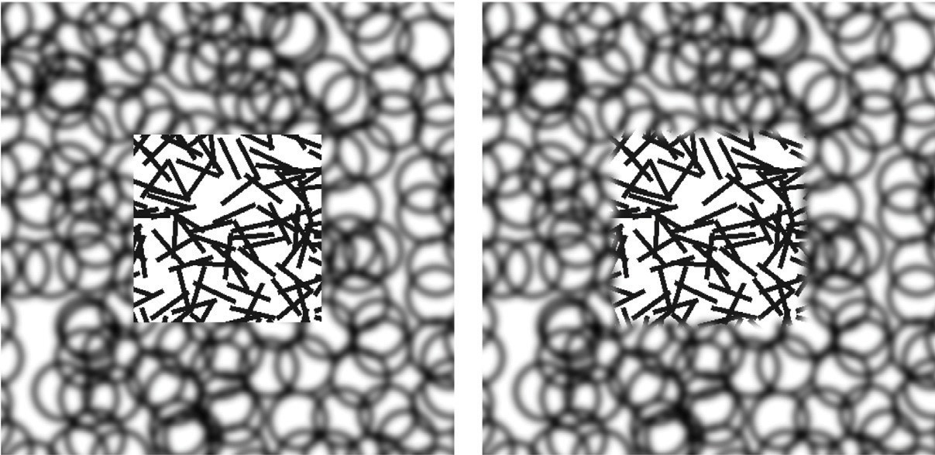

**Figure 20.20.** Does the central square appear in front of the pattern of circles or is it seen as appearing through a square hole in the pattern of circles? The only difference in the two images is the sharpness of the edge between the line and circle patterns (Marshall, Burbeck, Arely, Rolland, and

Martin (1999), used by permission).



θ

*ipd*

*z*

**Figure 20.21.** The *vergence* of the two eyes provides information about the distance to the point on which the eyes are fixated.

where *z* is the distance to a point in the world, *ipd* is the *interpupillary distance* indicating the distance between the eyes, and *θ* is the *vergence angle* indicating the orientation of the eyes relative to straight ahead. For small *θ*, which is the case for the geometric configuration of human eyes, tan *θ ≈ θ* when *θ* is expressed in radians. Thus, differences in vergence angle specify differences in depth by the following relationship:

*ipd* 1

Δ*θ ≈* 2 *·* Δ*z .* (20.6)

As *θ →* 0 in uniform steps, Δ*z* gets increasingly larger. This means that stereo vision is less sensitive to changes in depth as the overall depth increases. Conver- gence in fact only provides information on absolute depth for distances out to a few meters. Beyond that, changes in distance produce changes in vergence angle that are too small to be useful.

There is an interaction between accommodation and convergence in the hu- man visual system: accommodation is used to help determine the appropriate vergence angle, while vergence angle is used to help set the focus distance. Nor- mally, this helps the visual system when there is uncertainty is setting either ac- commodation or vergence. However, stereographic computer displays break the relationship between focus and convergence that occurs in the real world, leading to a number of perceptual difficulties (Wann, Rushton, & Mon-Williams, 1995).

* + 1. Binocular Disparity

The vergence angle of the eyes, when fixated on a common point in space, is only one of the ways that the visual system is able to determine depth from binocular stereo. A second mechanism involves a comparison of the retinal images in the

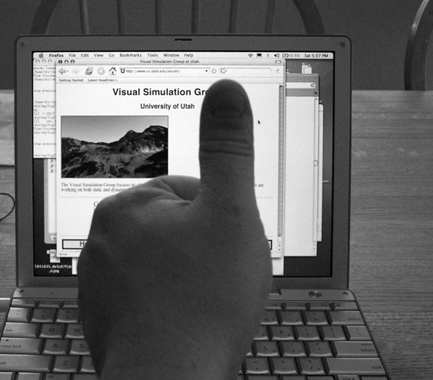 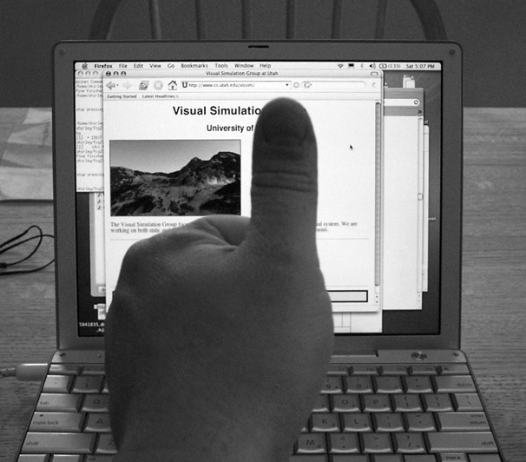

(left eye image) (right eye image)

**Figure 20.22.** Binocular disparity. The view from the left and right eyes shows an offset for surface points at depths different from the point of fixation. *Images courtesy Peter Shirley.*

two eyes and does not require information about where the eyes are pointed. A simple example demonstrates the effect. Hold your arm straight out in front of you, with your thumb pointed up. Stare at your thumb and then close one eye. Now, simultaneously open the closed eye and close the open eye. Your thumb will appear to be more or less stationary, while the more distant surfaces seen behind your thumb will appear to move from side to side (Figure 20.22). The change in retinal position of points in the scene between the left and right eyes is called *disparity*.

The binocular disparity cue requires that the vision system be able to match the image of points in the world in one eye with the imaged locations of those points in the other eye, a process referred to as the *correspondence problem*. This is a relatively complicated process and is only partially understood. Once cor- respondences have been established, the relative positions on which particular points in the world project onto the left and right retinas indicate whether the points are closer than or farther away than the point of fixation. *Crossed disparity* occurs when the corresponding points are displaced outward relative to the fovea and indicates that the surface point is closer than the point of fixation. *Uncrossed disparity* occurs when the corresponding points are displaced inward relative to the fovea and indicates that the surface point is farther away than the point of fixation (Figure 20.23).4 Binocular disparity is a relative depth cue, but it can provide information about absolute depth when scaled by convergence. Equation (20.5) applies to binocular disparity as well as binocular convergence. As with

4 Technically, crossed and uncrossed disparities indicate that the surface point generating the dis-

parity is closer to or farther away from the *horopter*. The horopter is not a fixed distance away from the eyes but rather it is a curved surface passing through the point of fixation.

Nearer point

More distant point

Crossed Uncrossed

disparity disparity

Fixation point

**Figure 20.23.** Near the line of sight, surface points nearer than the fixation point produce disparities in the opposite direction from those associated with surface points more distant than the fixation point.

convergence, the sensitivity of binocular disparity to changes in depth decreases with depth.

* + 1. Motion Cues

Relative motion between the eyes and visible surfaces will produce changes in the image of those surfaces on the retina. Three-dimensional relative motion between the eye and a surface point produces two-dimensional motion of the projection of the surface point on the retina. This retinal motion is given the name *optic flow*. Optic flow serves as the basis for several types of depth cues. In addition, optic flow can be used to determine information about how a person is moving in the world and whether or not a collision is imminent (Section 20.4.3).

If a person moves to the side while continuing to fixate on some surface point, then optic flow provides information about depth similar to stereo disparity. This is referred to as *motion parallax*. For other surface points that project to reti- nal locations near the fixation point, zero optic flow indicates a depth equivalent to the fixation point; flow in the opposite direction to head translation indicates nearer points, equivalent to crossed disparity; and flow in the same direction as head translation indicates farther points, equivalent to uncrossed disparity (Fig- ure 20.24). Motion parallax is a powerful cue to relative depth. In principle, motion parallax can provide absolute depth information if the visual system has access to information about the velocity of head motion. In practice, motion par- allax appears at best to be a weak cue for absolute depth.

In addition to egocentric depth information due to motion parallax, visual motion can also provide information about the three-dimensional shape of ob- jects moving relative to the viewer. In the perception literature, this is known as the *kinetic depth effect*. In computer vision, it is referred to as *structure-from-*

(a) (b)

**Figure 20.24.** (a) Motion parallax generated by sideways movement to the right while looking at an extended ground plane. (b) The same motion, with eye tracking of the fixation point.

*motion*. The kinetic depth effect presumes that one component of object motion is *rotation in depth*, meaning that there is a component of rotation around an axis perpendicular to the line of sight.

Optic flow can also provide information about the shape and location of sur- face boundaries, as shown in Figure 20.25. Spatial discontinuities in optic flow almost always either correspond to depth discontinuities or result from indepen- dently moving objects. Simple comparisons of the magnitude of optic flow are insufficient to determine the sign of depth changes, except in the special case of a viewer moving through an otherwise static world. Even when independently moving objects are present, however, the sign of the change in depth across sur- face boundaries can often be determined by other means. Motion often changes the portion of the more distant surface visible at surface boundaries. The appear- ance (*accretion*) or disappearance (*deletion*) of surface texture occurs because the nearer, occlud*ing* surface progressively uncovers or covers portions of the more distant, occlud*ed* surface. Comparisons of the motion of surface texture to either side of a boundary can also be used to infer ordinal depth, even in the absence of accretion or deletion of the texture. Discontinuities in optic flow and accre- tion/deletion of surface texture are referred to as *dynamic occlusion* cues and are another powerful source of visual information about the spatial structure of the environment.

The speed that a viewer is traveling relative to points in the world cannot be determined from visual motion alone (see Section 20.4.3). Despite this limitation, it is possible to use visual information to determine the time it will take to reach a visible point in the world, even when speed cannot be determined. When velocity is constant, *time-to-contact* (often referred to as *time-to-collision*) is given by the retinal size of an entity toward which the observer is moving, divided by the rate at which that image size is increasing.5 In the biological vision literature, this is

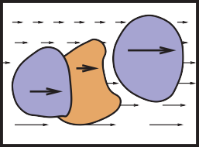

***A***

***C***

***B***

**Figure 20.25.** Discon- tinuities in optic flow signal surface boundaries. In many cases, the sign of the depth change (i.e., the ordinal depth) can be determined.

5 The terms time-to-collision and time-to-contact are misleading, since contact will only occur if the viewer’s trajectory actually passes through or near the entity under view.

often called the *τ function* (Lee & Reddish, 1981). If distance information to the structure in the world on which the time-to-collision estimate is based is available, then this can be used to determine speed.

* + 1. Pictorial Cues

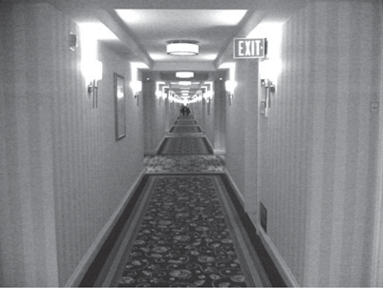

**Figure 20.26.** The clas- sical linear perspective effects include object size scaled by distance, the convergence of parallel lines, the ground plane extending to a visible horizon, and position on the ground plane relative to the horizon. *Image courtesy Sam Pullara.*

An image can contain much information about the spatial structure of the world from which it arose, even in the absence of binocular stereo or motion. As evi- dence for this, note that the world still appears three-dimensional even if we close one eye, hold our head stationary, and nothing moves in the environment. (As discussed in Section 20.5, the situation is more complicated in the case of pho- tographs and other displayed images.) There are three classes of such *pictorial depth cues*. The best known of these involve *linear perspective*. There are also a number of *occlusion cues* that provide information about ordinal depth even in the absence of perspective. Finally, *illumination cues* involving shading, shadows and interreflections, and aerial perspective also provide visual information about spatial layout.

The term *linear perspective* is often used to refer to properties of images in- volving object size in the image scaled by distance, the convergence of parallel lines, the ground plane extending to a visible horizon, and the relationship be- tween the distance to objects on the ground plane and the image location of those objects relative to the horizon (Figure 20.26). More formally, linear perspective cues are those visual cues which exploit the fact that under perspective projection, the image location onto which points in the world are projected is scaled by 1 , where *z* is the distance from the point of projection to the point in the environ- ment. Direct consequences of this relationship are that points that are farther away are projected to points closer to the center of the image (convergence of parallel lines) and that the spacing between the image of points in the world decreases for more distant world points (object size in the image is scaled by distance).6 The fact that the image of an infinite flat surface in the world ends at a finite horizon is explained by examining the perspective projection equation as *z → ∞*.

*z*

With the exception of size-related effects described in Section 20.4.2, most pictorial depth cues involving linear perspective depend on objects of interest be- ing in contact with a ground plane. In effect, these cues estimate not the distance to the objects but, instead, the distance to the contact point on the ground plane. Assuming observer and object are both on top of a horizontal ground plane, then

6The actual mathematics for analyzing the specifics of biological vision are different, since eyes are not well approximated by the planar projection formulation used in computer graphics and most other imaging applications.



θ

*d* = *h* cot θ

*h*

*d*

**Figure 20.27.** Absolute distance to locations on the ground plane can be determined based on declination angle from the horizon and eye height.

locations on the ground plane lower in the view will be close. Figure 20.27 illus- trates this effect quantitatively. For a viewpoint *h* above the ground and an *angle of declination θ* between the horizon and a point of interest on the ground, the point in question is a distance *d* = *h* cot *θ* from the point at which the observer is standing. The angle of declination provides relative depth information for arbi- trary fixed viewpoints and can provide absolute depth when scaling by eye height

1. is possible.

While the human visual system almost certainly makes use of angle of decli- nation as a depth cue, the exact mechanisms used to acquire the needed informa- tion are not clear. The angle *θ* could be obtained relative to either gravity or the visible horizon. There is some evidence that both are used in human vision. Eye height *h* could be based on posture, visually determined by looking at the ground at one’s feet, or learned by experience and presumed to be constant. While a number of researchers have investigated this issue, if and how these values are determined is not yet known with certainty.

Shadows provide a variety of types of information about three-dimensional spatial layout. *Attached shadows* indicate that an object is in contact with another surface, often consisting of the ground plane. *Detached shadows* indicate that an object is close to some surface, but not in contact with that surface. Shadows can serve as an indirect depth cue by causing an object to appear at the depth of the location of the shadow on the ground plane (Yonas, Goldsmith, & Hallstrom, 1978). When utilizing this cue, the visual system seems to make the assumption that light is coming from directly above (Figure 20.28).

Vision provides information about surface orientation as well as distance. It is convenient to represent visually determined surface orientation in terms of *tilt*, defined as the orientation in the image of the projection of the surface normal, and *slant*, defined as the angle between the surface normal and the line of sight.

**Figure 20.28.** Shadows can indirectly function as a depth cue by associating the depth of an object with a location on the ground plane (after Kersten, Mamassian, and Knill (1997)).

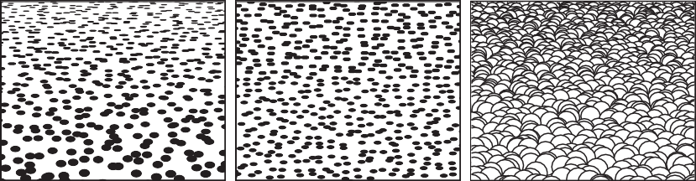

* 1. (b) (c)

**Figure 20.29.** Texture cues for slant. (a) Near surface exhibiting compression and texture gradient;

* 1. distant surface exhibiting only compression; (c) variability in appearance of near surface with regular geometric variability.

A visible surface horizon can be used to find the orientation of an (effectively infinite) surface relative to the viewer. Determining tilt is straightforward, since the tilt of the surface is the orientation of the visible horizon. Slant can be re- covered as well, since the lines of sight from the eye point to the horizon define a plane parallel to the surface. In many situations, either the surface horizon is not visible or the surface is small enough that its far edge does not correspond to an actual horizon. In such cases, visible texture can still be used to estimate orientation.

In the context of perception, the term *texture* refers to visual patterns consist- ing of sub-patterns replicated over a surface. The sub-patterns and their distri- bution can be fixed and regular, as for a checkerboard, or consistent in a more statistical sense, as in the view of a grassy field.7 When a textured surface is viewed from an oblique angle, the projected view of the texture is distorted rela- tive to the actual markings on the surface. Two quite distinct types of distortions occur (Knill, 1998), both affected by the amount of slant. The position and size of texture elements are subject to the linear perspective effects described above. This produces a *texture gradient* (Gibson, 1950) due to both element size and spacing decreasing with distance (Figure 20.29(a)). Both the image of individual

7In computer graphics, the term *texture* has a different meaning, referring to any image that is

applied to a surface as part of the rendering process.

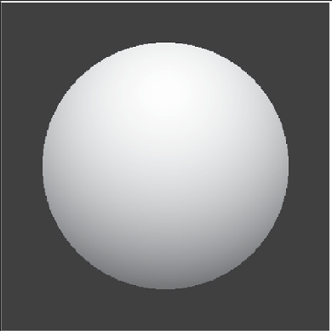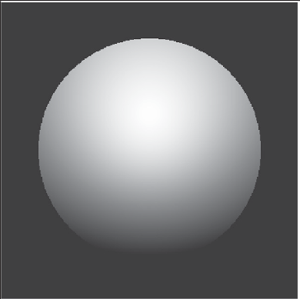

(a) (b)

**Figure 20.30.** Shape-from-shading. The images in (a) and (b) appear to have different 3D shapes because of differences in the rate of change of brightness over their surfaces.

texture elements and the distribution of elements are *foreshortened* under oblique viewing (Figure 20.29(b)). This produces a compression in the direction of tilt. For example, an obliquely viewed circle appears as an ellipse, with the ratio of the minor to major axes equal to the cosine of the slant. Note that foreshortening it- self is not a result of linear perspective, though in practice both linear perspective and foreshortening provide information about slant.8

For texture gradients to serve as a cue to surface slant, the average size and spacing of texture elements must be constant over the textured surface. If spa- tial variability in size and spacing in the image is not due in its entirely to the projection process, then attempts to invert the effects of projection will produce incorrect inferences about surface orientation. Likewise, the foreshortening cue fails if the shape of texture elements is not isotropic, since then asymmetric tex- ture element image shapes would occur in situations not associated with oblique viewing. These are examples of the assumptions often required in order for spa- tial visual cues to be effective. Such assumptions are reasonable to the degree that they reflect commonly occurring properties of the world.

Shading also provides information about surface shape (Figure 20.30). The brightness of viewed points on a surface depends on the surface reflectance and the orientation of the surface with respect to directional light sources and the observation point. When the relative position of an object, viewing direction, and illumination direction remain fixed, changes in brightness over a constant

8 A third form of visual distortion occurs when surfaces with distinct 3D surface relief are viewed obliquely (Leung & Malik, 1997), as shown in Figure 20.29(c). Nothing is currently known about if or how this effect might be used by the human vision system to determine slant.



**Figure 20.31.** Shading can generate a strong perception of three-dimensional shape. In this figure, the effect is stronger if you view the image from several meters away using one eye. It becomes yet stronger if you place a piece of cardboard in front of the figure with a hole cut out slightly smaller than the picture (see Section 20.5). *Image courtesy Albert Yonas.*

reflectance surface are indications of changes in the orientation of the surface of the object. *Shape-from-shading* is the process of recovering surface shape from these variations in observed brightness. It is almost never possible to recover the actual orientation of surfaces from shading alone, though shading can often be combined with other cues to provide an effective indication of surface shape. For surfaces with fine-scale geometric variability, shading can provide a compelling three-dimensional appearance, even for an image rendered on a two-dimensional surface (Figure 20.31).

There are a number of pictorial cues that yield ordinal information about depth, without directly indicating actual distance. In line drawings, different types of junctions provide constraints on the 3D geometry that could have generated the drawing (Figure 20.32). Many of these effects occur in more natural images as well. Most perceptually effective of the junction cues are *T-junctions*, which are strong indicators that the surface opposite the stem of the T is occluding at least one more distant surface. T-junctions often generate a sense of *amodal comple- tion*, in which one surface is seen to continue behind a nearer, occluding surface (Figure 20.33).

Atmospheric effects cause visual changes that can provide information about depth, particularly outdoors over long distances. Leonardo da Vinci was the first

T L

(a)

Arrow

(b)

Fork

**Figure 20.32.** (a) Junctions provide information about occlusion and the convexity or concavity of corners. (b) Common junction types for planar surface objects.

**Figure 20.33.** T-junctions cause the left disk to appear to be continuing behind the rectangle, while the right disk appears in front of the rectangle, which is seen to continue behind the disk.

to describe *aerial perspective* (also called *atmospheric perspective*), in which scattering reduces the contrast of distant portions of the scene and causes them to appear more bluish than if they were nearer (da Vinci, 1970) (see Figure 20.34). Aerial perspective is predominately a relative depth cue, though there is some speculation that it may affect perception of absolute distance as well. While many people believe that more distant objects look blurrier due to atmospheric effects, atmospheric scattering actually causes little blur.

## Objects, Locations, and Events

While there is fairly wide agreement among current vision scientists that the pur- pose of vision is to extract information about objects, locations, and events, there is little consensus on the key features of what information is extracted, how it is extracted, or how the information is used to perform tasks. Significant contro- versies exist about the nature of object recognition and the potential interactions between object recognition and other aspects of perception. Most of what we know about location involves low-level spatial vision, not issues associated with spatial relationships between complex objects or the visual processes required to



**Figure 20.34.** Aerial perspective, in which atmospheric effects reduce contrast and shift colors toward blue, provides a depth cue over long distances.

navigate in complex environments. We know a fair amount about how people perceive their speed and heading as they move through the world, but have only a limited understanding of actual event perception. Visual attention involves aspects of the perception of objects, locations, and events. While there is much data about the phenomenology of visual attention for relatively simple and well-controlled stimuli, we know much less about how visual attention serves high-level percep- tual goals.

* + 1. Object Recognition

Object recognition involves segregating an image into constituent parts corre- sponding to distinct physical entities and determining the identity of those entities. Figure 20.35 illustrates a few of the complexities associated with this process. We have little difficulty recognizing that the image on the left is some sort of vehi- cle, even though we have never before seen this particular view of a vehicle nor do most of us typically associate vehicles with this context. The image on the right is less easily recognizable until the page is turned upside down, indicating an orientational preference in human object recognition.

Object recognition is thought to involve two, fairly distinct steps. The first step organizes the visual field into *groupings* likely to correspond to objects and surfaces. These grouping processes are very powerful (see Figure 20.36), though there is little or no conscious awareness of the low-level image features that gener-

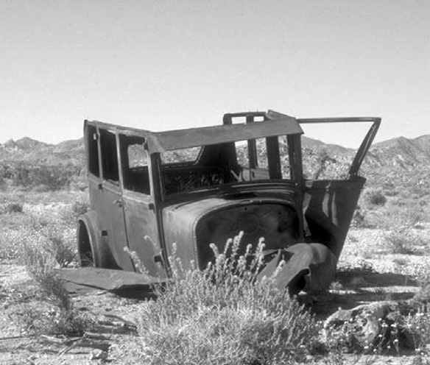 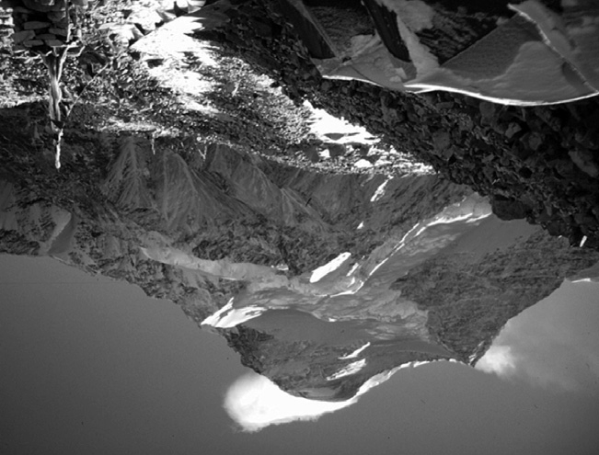

(a) (b)

**Figure 20.35.** The complexities of object recognition. (a) We recognize a vehicle-like object even though we have likely never seen this particular view of a vehicle before. (b) The image is hard to recognize based on a quick view. It becomes much easier to recognize if the book is turned upside down.

(a) (b)

**Figure 20.36.** Images are perceptually organized into groupings based on a complex set of simi- larity and organizational criteria. (a) Similarity in brightness results in four horizontal groupings. (b) Proximity resulting in three vertical groupings.

ate the grouping effect.9 Grouping is based on the complex interaction of proxim- ity, similarities in the brightness, color, shape, and orientation of primitive struc- tures in the image, common motion, and a variety of more complex relationships. The second step in object recognition is to interpret groupings as identified objects. A computational analysis suggests that there are a number of distinctly different ways in which an object can be identified. The perceptual data is unclear as to which of these are actually used in human vision. Object recognition requires that the vision system have available to it descriptions of each class of object

9 The most common form of visual camouflage involves adding visual textures that fool the per-

ceptual grouping processes so that the view of the world cannot be organized in a way that separates out the object being camouflaged.

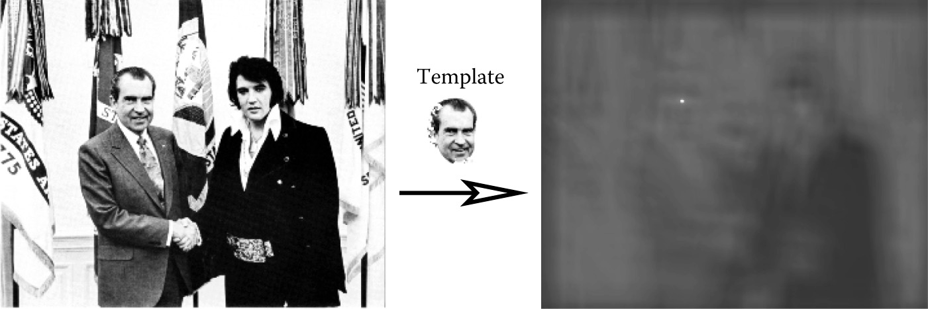

**Figure 20.37.** Template matching. The bright spot in the right image indicates the best match loca- tion to the template in the left image. *Image courtesy National Archives and Records Administration.*

sufficient to discriminate each class from all others. Theories of object recognition differ in the nature of the information describing each class and the mechanisms used to match these descriptions to actual views of the world.

Three general types of descriptions are possible. *Templates* represent object classes in terms of prototypical views of objects in each class. Figure 20.37 shows a simple example. *Structural descriptions* represent object classes in terms of dis- tinctive features of each class likely to be easily detected in views of the object, along with information about the geometric relationships between the features. Structural descriptions can either be represented in 2D or 3D. For 2D models of objects types, there must be a separate description for each distinctly differ- ent potential view of the object. For 3D models, two distinct forms of matching strategies are possible. In one, the three-dimensional structure of the viewed ob- ject is determined prior to classification using whatever spatial cues are available, and then this 3D description of the view is matched to 3D prototypes of known objects. The other possibility is that some mechanism allows the determination of the orientation of the yet-to-be identified object under view. This orientation information is used to rotate and project potential 3D descriptions in a way that allows a 2D matching of the description and the viewed object. Finally, the last option for describing the properties of object classes involves *invariant features* which describe classes of objects in terms of more generic geometric properties, particularly those that are likely be be insensitive to different views of the object.

* + 1. Size and Distance

In the absence of more definitive information about depth, objects which project onto a larger area of the retina are seen as closer compared with objects which project to a smaller retinal area, an effect called *relative size*. A more powerful cue involves *familiar size*, which can provide information for absolute distance

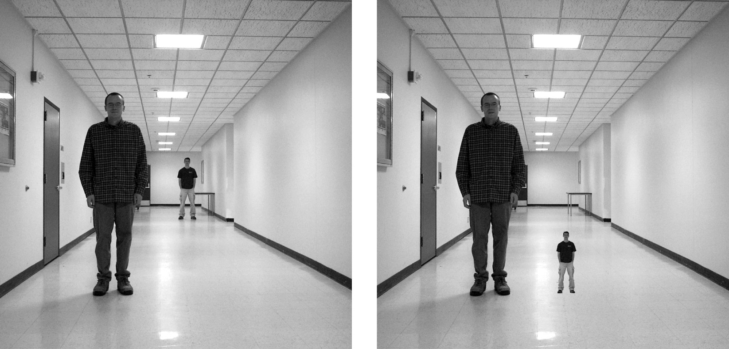

**Figure 20.38.** Left: perspective and familiar size cues are consistent. Right: perspective and familiar size cues are inconsistent. *Images courtesy Peter Shirley, Scott Kuhl, and J. Dylan Lacewell.*

to recognizable objects of known size. The strength of familiar size as a depth cue can be seen in illusions such as Figure 20.38, in which it is put in conflict with ground-plane, perspective-based depth cues. Familiar size is one part of the *size-distance* relationship, relating the physical size of an object, the optical size of the same object projected onto the retina, and the distance of the object from the eye (Figure 20.39).

When objects are sitting on top of a flat-ground plane, additional sources for depth information become available, particularly when the horizon is either vis- ible or can be derived from other perspective information. The angle of decli- nation to the contact point on the ground is a relative depth cue and provides absolute egocentric distance when scaled by eye height, as previously shown in

h



θ

Equation

d

**Figure 20.39.** The *size-distance relationship* allows the distance to objects of known size to be determined based on the visual angle subtended by the object. Likewise, the size of an object at a know distance can be determined based on the visual angle subtended by the object.

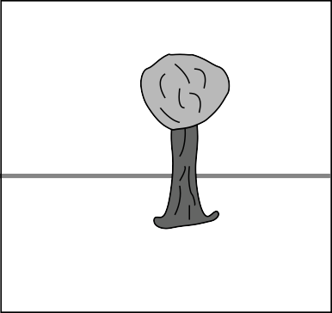

*v viewpoint height o object height*

s

*h*

**b**

**a**

**O ≈ v . *s***

**c**

***h***

* + - 1. (b)

**Figure 20.40.** (a) The *horizon ratio* can be used to determine depth by comparing the visible portion of an object below the horizon to the total vertical visible extent of the object. (b) A real-world example.

Figure 20.27. The *horizon ratio*, in which the total visible height of an object is compared with the visible extent of that portion of the object appearing below the horizon, can be used to determine the actual size of objects, even when the distance to the objects is not known (Figure 20.40). Underlying the horizon ratio is the fact that for a flat-ground plane, the line of sight to the horizon intersects objects at a position that is exactly an eye height above the ground.

The human visual system is sufficiently able to determine the absolute size of most viewed objects; our perception of size is dominated by the the actual physi-

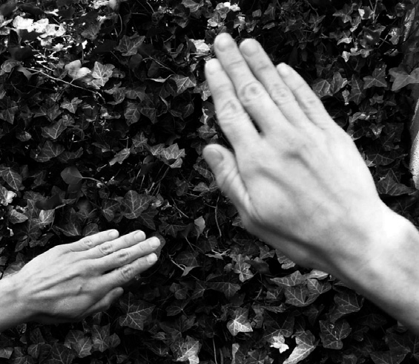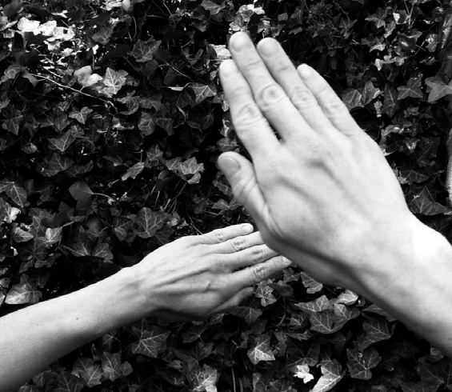

(a) (b)

**Figure 20.41.** (a) Size constancy makes hands positioned at different distances from the eye appear to be nearly the same size for real-world viewing, even though the retinal sizes are quite different. (b) The effect is less strong when one hand is partially occluded by the other, particularly when one eye is closed. *Images courtesy Peter Shirley and Pat Moulis.*

cal size, and we have almost no conscious awareness of the corresponding retinal size of objects. This is similar to lightness constancy, discussed earlier, in that our perception is dominated by inferred properties of the world, not the low level fea- tures actually sensed by photoreceptors in the retina. Gregory (1997) describes a simple example of *size constancy*. Hold your two hands out in front of you, one at arm’s length and the other at half that distance away from you (Figure 20.41(a)). Your two hands will look almost the same size, even though the retinal sizes differ by a factor of two. The effect is much less strong if the nearer hand partially oc- cludes the more distant hand, particularly if you close one eye (Figure 20.41(b)). The visual system also exhibits *shape constancy*, where the perception of geomet- ric structure is close to actual object geometry than might be expected given the distortions of the retinal image due to perspective (Figure 20.42).

* + 1. Events

Most aspects of event perception are beyond the scope of this chapter, since they involve complex nonvisual cognitive processes. Three types of event perception are primarily visual, however, and are also of clear relevance to computer graph- ics. Vision is capable of providing information about how a person is moving in the world, the existence of independently moving objects in the world, and the potential for collisions either due to observer motion or due to objects moving toward the observer.

Vision can be used to determine rotation and the direction of translation rel- ative to the environment. The simplest case involves movement toward a flat surface oriented perpendicularly to the line of sight. Presuming that there is suffi- cient surface texture to enable the recovery of optic flow, the flow field will form a symmetric pattern as shown in Figure 20.43(a). The location in the field of view of the *focus of expansion* of the flow field will have an associated line of sight corresponding to the direction of translation. While optic flow can be used to vi- sually determine the direction of motion, it does not contain enough information to determine speed. To see this, consider the situation in which the world is made twice as large and the viewer moves twice as fast. The decrease in the magnitude of flow values due to the doubling of distances is exactly compensated for by the increase in the magnitude of flow values due to the doubling of velocity, resulting in an identical flow field.

Figure 20.43(b) shows the optic flow field resulting from the viewer (or more accurately, the viewer’s eyes) rotating around the vertical axis. Unlike the situa- tion with respect to translational motion, optic flow provides sufficient informa- tion to determine both the axis of rotation and the (angular) speed of rotation. The

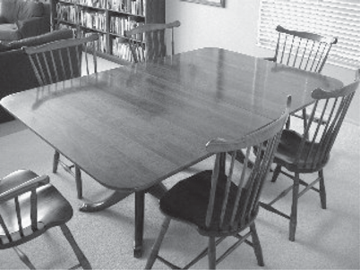

**Figure 20.42.** Shape constancy—the table looks rectangular even though its shape in the image is an irregular four-sided polygon.



|  |  |  |
| --- | --- | --- |
|  |  |  |
|  |
|  |
|  |  |
|  |  |
|  |
|  |

* + - 1. (b) (c)

**Figure 20.43.** (a) Movement toward a flat, textured surface produces an expanding flow field, with the *focus of expansion* indicating the line of sight corresponding to the direction of motion. (b) The flow field resulting from rotation around the vertical axis while viewing a flat surface oriented perpendicularly to the line of sight. (c) The flow field resulting from translation parallel to a flat, textured surface.

practical problem in exploiting this is that the flow resulting from pure rotational motion around an axis perpendicular to the line of sight is quite similar to the flow resulting from pure translation in the direction that is perpendicular to both the line of sight and this rotational axis, making it difficult to visually discriminate between the two very different types of motion (Figure 20.43(c)). Figure 20.44 shows the optical flow patterns generated by movement through a more realistic environment.

If a viewer is completely stationary, visual detection of moving objects is easy, since such objects will be associated with the only nonzero optic flow in the field of view. The situation is considerably more complicated when the observer is moving, since the visual field will be dominated by nonzero flow, most or all of



**Figure 20.44.** The optic flow generated by moving through an otherwise static environment pro- vides information about both the motion relative to the environment and the distances to points in the environment. In this case, the direction of view is depressed from the horizon, but as indicated by the focus of expansion, the motion is parallel to the ground plane.

which is due to relative motion between the observer and the static environment (Thompson & Pong, 1990). In such cases, the visual system must be sensitive to patterns in the optic flow field that are inconsistent with flow fields associated with observer movement relative to a static environment (Figure 20.45).

Section 20.3.4 described how vision can be used to determine time to contact with a point in the environment even when the speed of motion is not known. Assuming a viewer moving with a straight, constant-speed trajectory and no in- dependently moving objects in the world, contact will be made with whatever surface is in the direction of the line of sight corresponding to the focus of expan- sion at a time indicated by the *τ* relationship. An independently moving object complicates the matter of determining if a collision will in fact occur. Sailors use a method for detecting potential collisions that may also be employed in the hu- man visual system: for non-accelerating straight-line motion, collisions will occur with objects that are visually expanding but otherwise remain visually stationary in the egocentric frame of reference.

One form of more complex event perception merits discussion here, since it is so important in interactive computer graphics. People are particularly sensitive to motion corresponding to human movement. Locomotion can be recognized when the only features visible are lights on the walker’s joints (Johansson, 1973). Such *moving light displays* are often even sufficient to recognize properties such as the sex of the walker and the weight of the load that the walker may be carrying. In computer graphics renderings, viewers will notice even small inaccuracies in animated characters, particularly if they are intended to mimic human motion.

The term *visual attention* covers a range of phenomenon from where we point our eyes to cognitive effects involving what we notice in a complex scene and how we interpret what we notice (Pashler, 1998). Figure 20.46 provides an example of how attentional processes affect vision, even for very simple images. In the left



**Figure 20.45.** Visual de- tection of moving objects from a moving observation point requires recognizing patterns in the optic flow that can- not be associated with motion through a static environment.



(a) (b) (c)

**Figure 20.46.** In (a) and (b), visual attention is quickly drawn to the item of different shape or color. In (c), sequential search appears to be necessary in order to find the one item that differs in both shape and color.

two panels, the one pattern differing in shape or color from the rest immediately “pops out” and is easily noticed. In the panel on the right, the one pattern differ- ing in both shape and color is harder to find. The reason for this is that the visual system can do a parallel search for items distinguished by individual properties, but requires more cognitive, sequential search when looking for items that are in- dicated by the simultaneous presence of two distinguishing features. Graphically based human-computer interfaces should be (but often are not!) designed with an understanding of how to take advantage of visual attention processes in people so as to communicate important information quickly and effectively.

## Picture Perception

So far, this chapter has dealt with the visual perception that occurs when the world is directly imaged by the human eye. When we view the results of computer graphics, of course, we are looking at rendered images and not the real world. This has important perceptual implications. In principle, it should be possible to generate computer graphics that appear indistinguishable from the real world, at least for monocular viewing without either object or observer motion. Imagine looking out at the world through a glass window. Now, consider coloring each point on the window to exactly match the color of the world originally seen at that point.10 The light reaching the eye is unchanged by this operation, meaning that perception should be the same whether the painted glass is viewed or the real world is viewed through the window. The goal of computer graphics can be thought of as producing the colored window without actually having the equiva- lent real-world view available.

The problem for computer graphics and other visual arts is that we can’t in practice match a view of the real world by coloring a flat surface. The bright- ness and dynamic range of light in the real world is impossible to re-create using any current display technology. Resolution of rendered images is also often less that the finest detail perceivable by human vision. Lightness and color constancy are much less apparent in pictures than in the real world, likely because the vi- sual system attempts to compensate for variability in the brightness and color of the illumination based on the ambient illumination in the viewing environment, rather than the illumination associated with the rendered image. This is why the realistic appearance of color in photographs depends on film color balanced for the nature of the light source present when the photograph was taken and why

10This idea was first described by the painter Leon Battista Alberti in 1435 and is now known as

*Alberti’s Window*. It is closely related to the *camera obscura*.

realistic color in video requires a white-balancing step. While much is known about how limitations in resolution, brightness, and dynamic range affect the de- tectability of simple patterns, almost nothing is known about how these display properties affect spatial vision or object identification.

We have a better understanding of other aspects of this problem, which psy- chologists refer to as the perception of *pictorial space* (S. Rogers, 1995). One difference between viewing images and viewing the real world is that accom- modation, binocular stereo, motion parallax, and perhaps other depth cues may indicate that the surface under view is much different from the distances in the world that it is intended to represent. The depths that are seen in such a situation tend to be somewhere between the depths indicated by the pictorial cues in the image and the distance to the image itself. When looking at a photograph or com- puter display, this often results in a sense of scale smaller than intended. On the other hand, seeing a movie in a big-screen theater produces a more compelling sense of spaciousness than does seeing the same movie on television, even if the distance to the TV is such that the visual angles are the same, since the movie screen is farther away.

Computer graphics rendered using perspective projection has a viewpoint, specified as a position and direction in model space, and a view frustum, which specifies the horizontal and vertical field of view and several other aspects of the viewing transform. If the rendered image is not viewed from the correct location, the visual angles to the borders of the image will not match the frustum used in creating the image. All visual angles within the image will be distorted as well, causing a distortion in all of the pictorial depth and orientation cues based on linear perspective. This effect occurs frequently in practice, when a viewer is po- sitioned either too close or too far away from a photograph or display surface. If the viewer is too close, the perspective cues for depth will be compressed, and the cues for surface slant will indicate that the surface is closer to perpendicular to the line of sight than is actually the case. The situation is reversed if the viewer is too far from the photograph or screen. The situation is even more complicated if the line of sight does not go through the center of the viewing area, as is commonly the case in a wide variety of viewing situations.

The human visual system is able to partially compensate for perspective dis- tortions arising from viewing an image at the wrong location, which is why we are able to sit in different seats at a movie theater and experience a similar sense of the depicted space. When controlling viewing position is particularly impor- tant, *viewing tubes* can be used. These are appropriately sized tubes, mounted in a fixed position relative to the display, and through which the viewer sees the display. The viewing tube constrains the observation point to the (hopefully) cor-

rect position. Viewing tubes are also quite effective at reducing the conflict in depth information between the pictorial cues in the image and the actual display surface. They eliminate both stereo and motion parallax, which, if present, would correspond to the display surface, not the rendered view. If they are small enough in diameter, they also reduce other cues to the location of the display surface by hiding the picture frame or edge of the display device. Exotic visually immersive display devices such as head-mounted displays (HMDs) go further in attempting to hide visual cues to the position of the display surface while adding binocu- lar stereo and motion parallax consistent with the geometry of the world being rendered.

rd

|  |  |  |
| --- | --- | --- |
|  | Erik | Reinha |
|  | 21 |  |
|  |  |  |

# Tone Reproduction

As discussed in Chapter 20, the human visual system adapts to a wide range of viewing conditions. Under normal viewing, we may discern a range of around 4 to 5 log units of illumination, i.e., the ratio between brightest and darkest areas where we can see detail may be as large as 100*,*000 : 1. Through adaptation processes, we may adapt to an even larger range of illumination. We call images that are matched to the capabilities of the human visual system *high dynamic range*.

Visual simulations routinely produce images with a high dynamic range (Ward Larson & Shakespeare, 1998). Recent developments in image-capturing techniques allow multiple exposures to be aligned and recombined into a single high dynamic range image (Debevec & Malik, 1997). Multiple exposure tech- niques are also available for video. In addition, we expect future hardware to be able to photograph or film high dynamic range scenes directly. In general, we may think of each pixel as a triplet of three floating point numbers.

As it is becoming easier to create high dynamic range imagery, the need to display such data is rapidly increasing. Unfortunately, most current display de- vices, monitors and printers, are only capable of displaying around 2 log units of dynamic range. We consider such devices to be of low dynamic range. Most images in existence today are represented with a byte-per-pixel-per-color chan- nel, which is matched to current display devices, rather than to the scenes they represent.

Typically, low dynamic range images are not able to represent scenes with- out loss of information. A common example is an indoor room with an out-

559

**Figure 21.1.** With conventional photography, some parts of the scene may be under- or over- exposed. To visualize the snooker table, the view through the window is burned out in the left image. On the other hand, the snooker table will be too dark if the outdoor part of this scene is properly exposed. Compare with Figure 21.2, which shows a high dynamic range image prepared for display using a tone reproduction algorithm.

door area visible through the window. Humans are easily able to see details of both the indoor part and the outside part. A conventional photograph typically does not capture this full range of information—the photographer has to choose whether the indoor or the outdoor part of the scene is properly exposed (see Fig- ure 21.1). These decisions may be avoided by using high dynamic range imaging and preparing these images for display using techniques described in this chapter (see Figure 21.2).

There are two strategies available to display high dynamic range images. First,

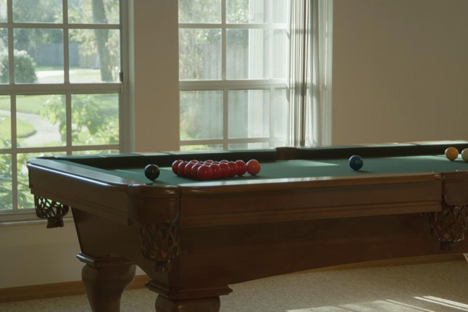we may develop display devices which can directly accommodate a high dy- namic range (Seetzen, Whitehead, & Ward, 2003; Seetzen et al., 2004). Sec- ond, we may prepare high dynamic range images for display on low dy- namic range display devices (Upstill, 1985). This is currently the more com- mon approach and the topic of this

**Figure 21.2.** A high dynamic range image tonemapped for display using a recent tone re- production operator (Reinhard & Devlin, 2005). In this image, both the indoor part and the view through the window are properly exposed.

chapter. Although we foresee that high dynamic range display devices will be- come widely used in the (near) future, the need to compress the dynamic range of an image may diminish, but will not

disappear. In particular, printed media such as this book are, by their very nature, low dynamic range.

Compressing the range of values of an image for the purpose of display on a low dynamic range display device is called tonemapping or tone reproduction.

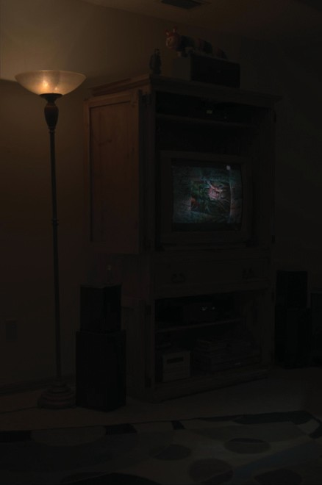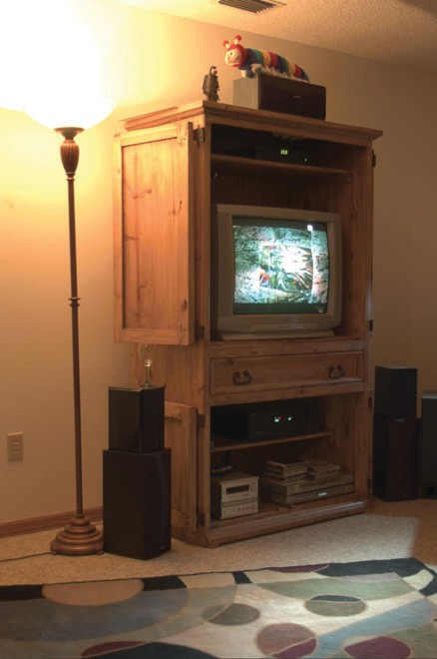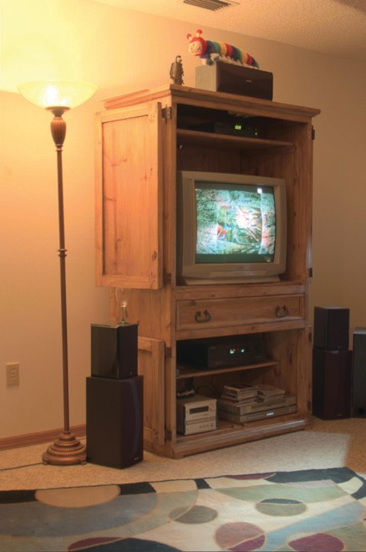

**Figure 21.3.** Linear scaling of high dynamic range images to fit a given display device may cause significant detail to be lost (left and middle). The left image is linearly scaled. In the middle image high values are clamped. For comparison, the right image is tonemapped, allowing details in both bright and dark regions to be visible.

A simple compression function would be to normalize an image (see Figure 21.3 (left)). This constitutes a linear scaling which tends to be sufficient only if the dy- namic range of the image is only marginally higher than the dynamic range of the display device. For images with a higher dynamic range, small intensity differ- ences will be quantized to the same display value such that visible details are lost. In Figure 21.3 (middle) all pixel values larger than a user-specified maximum are set to this maximum (i.e., they are clamped). This makes the normalization less dependent on noisy outliers, but here we lose information in the bright areas of the image. For comparison, Figure 21.3 (right) is a tonemapped version showing detail in both the dark and the bright regions.

In general, linear scaling will not be appropriate for tone reproduction. The key issue in tone reproduction is then to compress an image while at the same time preserving one or more attributes of the image. Different tone reproduction algorithms focus on different attributes such as contrast, visible detail, brightness, or appearance.

Ideally, displaying a tonemapped image on a low dynamic range display de- vice would create the same visual response in the observer as the original scene. Given the limitations of display devices, this will not be achievable, although we could aim for approximating this goal as closely as possible.

As an example, we created the high dynamic range image shown in Fig- ure 21.4. This image was then tonemapped and displayed on a display device. The display device itself was then placed in the scene such that it displays its own background (Figure 21.5). In the ideal case, the display should appear transpar-

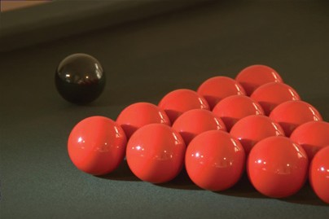

**Figure 21.4.** Image used for demonstrating the goal of tone reproduction in Figure 21.5.

**Figure 21.5.** After tonemapping the image in Figure 21.4 and displaying it on a monitor, the monitor is placed in the scene approximately at the location where the image was taken. Dependent on the quality of the tone reproduction operator, the result should appear as if the monitor is transparent.

ent. Dependent on the quality of the tone reproduction operator, as well as the nature of the scene being depicted, this goal may be more or less achievable.

## Classification

Although it would be possible to classify tone reproduction operators by which attribute they aim to preserve, or for which task they were developed, we classify algorithms according to their general technique. This will enable us to show the differences and similarities between a significant number of different operators, and so, hopefully, contribute to the meaningful selection of specific operators for given tone reproduction tasks.

The main classification scheme we follow hinges upon the realization that tone reproduction operators are based on insights gained from various disciplines. In particular, several operators are based on knowledge of human visual perception. The human visual system detects light using photoreceptors located in the retina. Light is converted to an electrical signal which is partially processed in the retina and then transmitted to the brain. Except for the first few layers of cells in the retina, the signal derived from detected light is transmitted using im- pulse trains. The information-carrying quantity is the frequency with which these

electrical pulses occur.

The range of light that the human visual system can detect is much larger than the range of frequencies employed by the human brain to transmit infor- mation. Thus, the human visual system effortlessly solves the tone reproduc- tion problem—a large range of luminances is transformed into a small range of frequencies of impulse trains. Emulating relevant aspects of the human visual system is therefore a worthwhile approach to tone reproduction; this approach is explained in more detail in Section 21.7.

A second class of operators is grounded in physics. Light interacts with sur- faces and volumes before being absorbed by the photoreceptors. In computer graphics, light interaction is generally modeled by the rendering equation. For purely diffuse surfaces, this equation may be simplified to the product between light incident upon a surface (illuminance), and this surface’s ability to reflect light (reflectance) (Oppenheim, Schafer, & Stockham, 1968).

Since reflectance is a passive property of surfaces, for diffuse surfaces it is, by definition, low dynamic range—typically between 0*.*005 and 1 (Stockham, 1972). The reflectance of a surface cannot be larger than 1, since then it would reflect more light than was incident upon the surface. Illuminance, on the other

hand, can produce arbitrarily large values and is limited only by the intensity and proximity of the light sources.

The dynamic range of an image is thus predominantly governed by the illu- minance component. In the face of diffuse scenes, a viable approach to tone re- production may therefore be to separate reflectance from illuminance, compress the illuminance component, and then recombine the image.

However, the assumption that all surfaces in a scene are diffuse is generally incorrect. Many high dynamic range images depict highlights and/or directly visible light sources (Figure 21.3). The luminance reflected by a specular surface may be almost as high as the light source it reflects.

Various tone reproduction operators currently used split the image into a high dynamic range base layer and a low dynamic range detail layer. These layers would represent illuminance and reflectance if the depicted scene were entirely diffuse. For scenes containing directly visible light sources or specular highlights, separation into base and detail layers still allows the design of effective tone re- production operators, although no direct meaning can be attached to the separate layers. Such operators are discussed in Section 21.5.

## Dynamic Range

Conventional images are stored with one byte per pixel for each of the red, green and blue components. The dynamic range afforded by such an encoding depends on the ratio between smallest and largest representable value, as well as the step size between successive values. Thus, for low dynamic range images, there are only 256 different values per color channel.

High dynamic range images encode a significantly larger set of possible val- ues; the maximum representable value may be much larger and the step size be- tween successive values may be much smaller. The file size of high dynamic



**Figure 21.6.** Dynamic

range of 2.65 log 2 units.



**Figure 21.7.** Dynamic

range of 3.96 log 2 units.



**Figure 21.8.** Dynamic

range of 4.22 log 2 units.

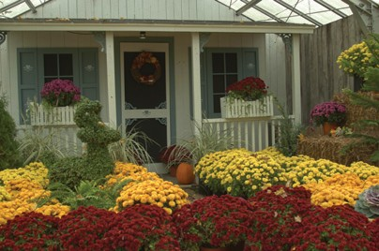

**Figure 21.9.** Dynamic

range of 5.01 log 2 units.

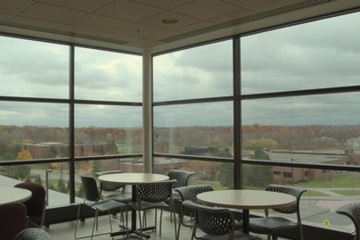

**Figure 21.10.** Dynamic

range of 6.56 log 2 units.

range images is therefore generally larger as well, although at least one standard (the OpenEXR high dynamic range file format (Kainz, Bogart, & Hess, 2003)) includes a very capable compression scheme.

A different approach to limit file sizes is to apply a tone reproduction operator to the high dynamic data. The result may then be encoded in JPEG format. In addition, the input image may be divided pixel-wise by the tonemapped image. The result of this division can then be subsampled and stored as a small amount of data in the header of the same JPEG image (G. Ward & Simmons, 2004). The file size of such sub-band encoded images is of the same order as conventional JPEG encoded images. Display programs can display the JPEG image directly or may reconstruct the high dynamic range image by multiplying the tonemapped image with the data stored in the header.

In general, the combination of smallest step size and ratio of the smallest and largest representable values determines the dynamic range that an image encoding scheme affords. For computer-generated imagery, an image is typically stored as a triplet of floating point values before it is written to file or displayed on screen, although more efficient encoding schemes are possible (Reinhard, Ward, Debevec, & Pattanaik, 2005). Since most display devices are still fitted with eight- bit D/A converters, we may think of tone reproduction as the mapping of floating point numbers to bytes such that the result is displayable on a low dynamic range display device.

The dynamic range of individual images is generally smaller, and is deter- mined by the smallest and largest luminances found in the scene. A simplistic approach to measure the dynamic range of an image may therefore compute the ratio between the largest and smallest pixel value of an image. Sensitivity to out- liers may be reduced by ignoring a small percentage of the darkest and brightest pixels.

Alternatively, the same ratio may be expressed as a difference in the logarith- mic domain. This measure is less sensitive to outliers. The images shown in the margin on this page are examples of images with different dynamic ranges. Note that the night scene in this case does not have a smaller dynamic range than the day scene. While all the values in the night scene are smaller, the ratio between largest and smallest values is not.

However, the recording device or rendering algorithm may introduce noise which will lower the useful dynamic range. Thus, a measurement of the dynamic range of an image should factor in noise. A better measure of dynamic range would therefore be a signal-to-noise ratio, expressed in decibels, as used in signal processing.

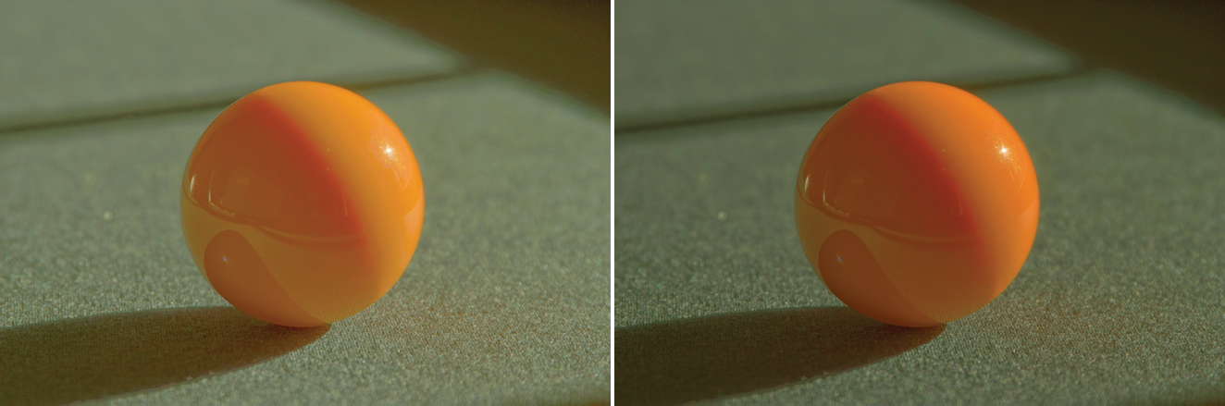

**Figure 21.11.** Per-channel gamma correction may desaturate the image. The left image was desaturated with a value of *s* = 0.5. The right image was not desaturated (*s* = 1).

## Color

Tone reproduction operators normally compress luminance values, rather than work directly on the red, green, and blue components of a color image. Af- ter these luminance values have been compressed into display values *Ld*(*x, y*), a color image may be reconstructed by keeping the ratios between color channels the same as they were before compression (using *s* = 1) (Schlick, 1994b):

*Ir,d*(*x, y*) =

*Ig,d*(*x, y*) =

*Ib,d*(*x, y*) =

*Lv*(*x, y*)

*Ig*(*x, y*) *s*

. Σ

. *Ir*(*x, y*) Σ*s*

*Lv*(*x, y*)

. Σ

*Ib*(*x, y*) *s*

*Lv*(*x, y*)

*Ld*(*x, y*)*,*

*Ld*(*x, y*)*,*

*Ld*(*x, y*)*.*

The results frequently appear over-saturated, because human color perception is nonlinear with respect to overall luminance level. This means that if we view an image of a bright outdoor scene on a monitor in a dim environment, our eyes are adapted to the dim environment rather than the outdoor lighting. By keeping color ratios constant, we do not take this effect into account.

Alternatively, the saturation constant *s* may be chosen smaller than one. Such per-channel gamma correction may desaturate the results to an appropriate level, as shown in Figure 21.11 (Fattal, Lischinski, & Werman, 2002). A more compre- hensive solution is to incorporate ideas from the field of color appearance mod- eling into tone reproduction operators (Pattanaik, Ferwerda, Fairchild, & Green- berg, 1998; Fairchild & Johnson, 2004; Reinhard & Devlin, 2005).

Finally, if an example image with a representative color scheme is already available, this color scheme may be applied to a new image. Such a mapping of colors between images may be used for subtle color correction, such as satura- tion adjustment or for more creative color mappings. The mapping proceeds by converting both source and target images to a decorrelated color space. In such a color space, the pixel values in each color channel may be treated independently without introducing too many artifacts (Reinhard, Ashikhmin, Gooch, & Shirley, 2001).

Mapping colors from one image to another in a decorrelated color space is then straightforward: compute the mean and standard deviation of all pixels in the source and target images for the three color channels separately. Then,

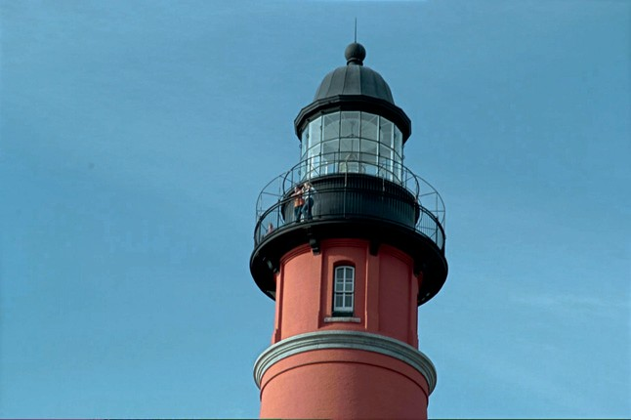shift and scale the target image so that in each color channel the mean and stan- dard deviation of the target image is the same as the source image. The result- ing image is then obtained by convert- ing from the decorrelated color space to RGB and clamping negative pixels to zero. The dynamic range of the image may have changed as a result of apply-

**Figure 21.12.** Image used for demonstrating the color transfer technique. Results are shown in Figures 21.13 and 21.31.

ing this algorithm. It is therefore recom- mended to apply this algorithm on high dynamic range images and apply a con-

ventional tone reproduction algorithm afterward. A suitable decorrelated color space is the opponent space from Section 19.2.4.

The result of applying such a color transform to the image in Figure 21.12 is shown in Figure 21.13.

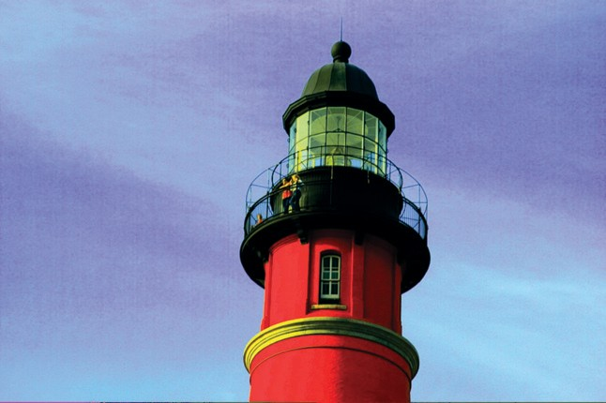

**Figure 21.13.** The image on the left is used to adjust the colors of the image shown in Figure 21.12. The result is shown on the right.

21.4. Image Formation 567

## Image Formation

For now, we assume that an image is formed as the result of light being diffusely reflected off of surfaces. Later in this chapter, we relax this constraint to scenes directly depicting light sources and highlights. The luminance *Lv* of each pixel is then approximated by the following product:

*Lv*(*x, y*) = *r*(*x, y*) *Ev*(*x, y*)*.*

Here, *r* denotes the reflectance of a surface, and *Ev* denotes the illuminance. The subscript *v* indicates that we are using photometrically weighted quantities. Al- ternatively, we may write this expression in the logarithmic domain (Oppenheim et al., 1968):

*D*(*x, y*) = log(*Lv*(*x, y*))

= log(*r*(*x, y*) *Ev*(*x, y*))

= log(*r*(*x, y*)) + log(*Ev*(*x, y*))*.*

Photographic transparencies record images by varying the density of the material. In traditional photography, this variation has a logarithmic relation with lumi- nance. Thus, in analogy with common practice in photography, we will use the term *density representation* (*D*) for log luminance. When represented in the log domain, reflectance and illuminance become additive. This facilitates separation of these two components, despite the fact that isolating either reflectance or il- luminance is an under-constrained problem. In practice, separation is possible only to a certain degree and depends on the composition of the image. Nonethe- less, tone reproduction could be based on disentangling these two components of image formation, as shown in the following two sections.

## Frequency-Based Operators

For typical diffuse scenes, the reflectance component tends to exhibit high spatial frequencies due to textured surfaces as well as the presence of surface edges. On the other hand, illuminance tends to be a slowly varying function over space.

Since reflectance is low dynamic range and illuminance is high dynamic range, we may try to separate the two components. The frequency-dependence of both reflectance and illuminance provides a solution. We may, for instance, compute the Fourier transform of an image and attenuate only the low frequencies. This compresses the illuminance component while leaving the reflectance component

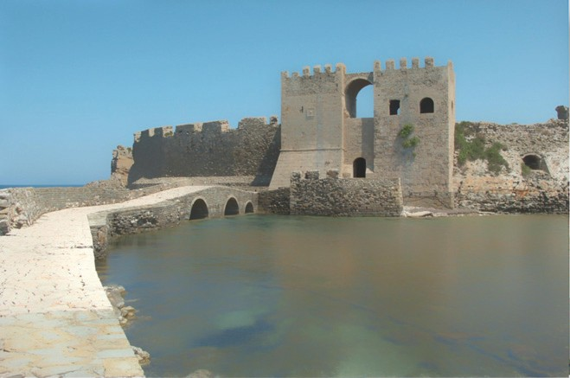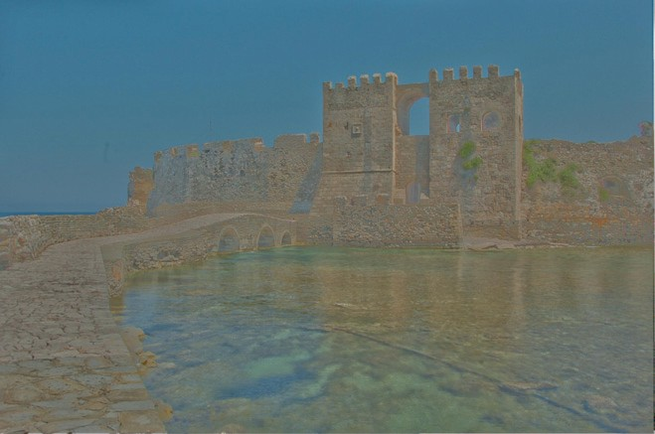

**Figure 21.14.** Bilateral filtering removes small details but preserves sharp gradients (left). The associated detail layer is shown on the right.

largely unaffected—the very first digital tone reproduction operator known to us takes this approach (Oppenheim et al., 1968).

More recently, other operators have also followed this line of reasoning. In particular, bilateral and trilateral filters were used to separate an image into base and detail layers (Durand & Dorsey, 2002; Choudhury & Tumblin, 2003). Both filters are edge-preserving smoothing operators which may be used in a variety of different ways. Applying an edge-preserving smoothing operator to a density im- age results in a blurred image in which sharp edges remain present (Figure 21.14 (left)). We may view such an image as a base layer. If we then pixel-wise divide the high dynamic range image by the base layer, we obtain a detail layer which contains all the high-frequency detail (Figure 21.14 (right)).

For diffuse scenes, base and detail layers are similar to representations of illuminance and reflectance. For images depicting highlights and light sources,

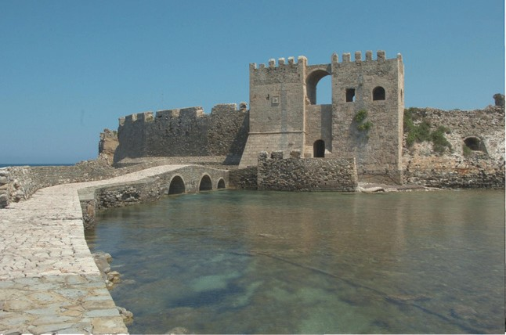this parallel does not hold. However, separation of an image into base and detail layers is possible regardless of the image’s content. By compressing the base layer before recombining into a compressed density image, a low dy- namic range density image may be cre- ated (Figure 21.15). After exponentia- tion, a displayable image is obtained.

**Figure 21.15.** An image tonemapped using bi- lateral filtering. The base and detail layers shown in Figure 21.14 are recombined after compress- ing the base layer.

Edge-preserving smoothing opera- tors may also be used to compute a local adaptation level for each pixel, which

may be used in a spatially varying or local tone reproduction operator. We de- scribe this use of bilateral and trilateral filters in Section 21.7.

**Figure 21.16.** The image on the left (tonemapped using gradient-domain compression) shows a scene with highlights. These highlights show up as large gradients on the right, where the magnitude of the gradients is mapped to a grayscale (black is a gradient of 0, white is the maximum gradient in the image).

## Gradient-Domain Operators

The arguments made for the frequency-based operators in the preceding section also hold for the gradient field. Assuming that no light sources are directly visible, the reflectance component will be a constant function with sharp spikes in the gradient field. Similarly, the illuminance component will cause small gradients everywhere.

Humans are generally able to separate illuminance from reflectance in typical scenes. The perception of surface reflectance after discounting the illuminant is called *lightness*. To assess the lightness of an image depicting only diffuse sur- faces, B. K. P. Horn was the first to separate reflectance and illuminance using a gradient field (Horn, 1974). He used simple thresholding to remove all small gra- dients and then integrated the image, which involves solving a Poisson equation using the Full Multigrid Method (Press, Teukolsky, Vetterling, & Flannery, 1992). The result is similar to an edge-preserving smoothing filter. This is accord- ing to expectation since Oppenheim’s frequency-based operator works under the same assumptions of scene reflectivity and image formation. In particular, Horn’s work was directly aimed at “mini-worlds of Mondrians,” which are simplified versions of diffuse scenes which resemble the abstract paintings by the famous

Dutch painter Piet Mondrian.

Horn’s work cannot be employed directly as a tone reproduction operator, since most high dynamic range images depict light sources. However, a relatively small variation will turn this work into a suitable tone reproduction operator. If light sources or specular surfaces are depicted in the image, then large gradients will be associated with the edges of light sources and highlights. These cause the image to have a high dynamic range. An example is shown in Figure 21.16, where the highlights on the snooker balls cause sharp gradients.

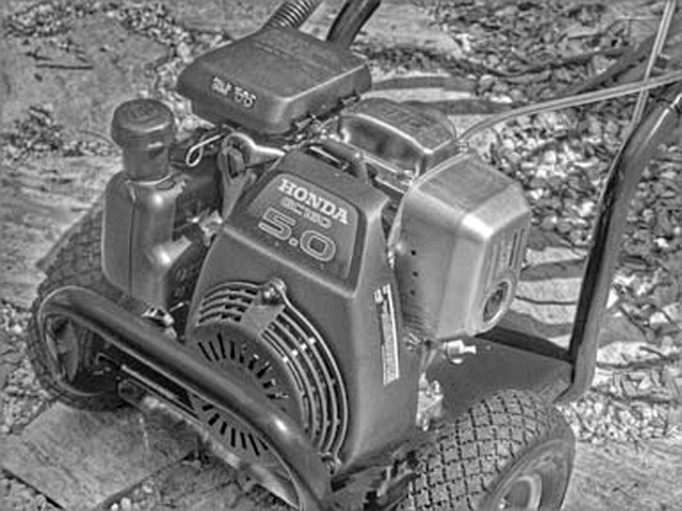

**Figure 21.17.** An image tonemapped using gradient-domain compression.

We could therefore compress a high dynamic range image by attenuating large gradients, rather than threshold- ing the gradient field. This approach was taken by Fattal et al. who showed that high dynamic range imagery may be successfully compressed by integrat- ing a compressed gradient field (Fig- ure 21.17) (Fattal et al., 2002). Fat- tal’s gradient-domain compression is not limited to diffuse scenes.

## Spatial Operators

In the following sections, we discuss tone reproduction operators which apply compression directly on pixels without transformation to other domains. Often global and local operators are distinguished. Tone reproduction operators in the former class change each pixel’s luminance values according to a compressive function which is the same for each pixel. The term global stems from the fact that many such functions need to be anchored to some values determined by analyzing the full image. In practice, most operators use the geometric average *L*¯*v* to steer the compression:

*L*¯ = exp . 1 Σ log(*δ* + *L* (*x, y*)Σ *.* (21.1)

*x,y*

*v*

*N*

*v*

In Equation (21.1), a small constant *δ* is introduced to prevent the average to be- come zero in the presence of black pixels. The geometric average is normally mapped to a predefined display value. The effect of mapping the geometric aver- age to different display values is shown in Figure 21.18. Alternatively, sometimes the minimum or maximum image luminance is used. The main challenge faced in the design of a global operator lies in the choice of the compressive function.

On the other hand, local operators compress each pixel according to a specific compression function which is modulated by information derived from a selection of neighboring pixels, rather than the full image. The rationale is that a bright pixel in a bright neighborhood may be perceived differently than a bright pixel in a dim neighborhood. Design challenges in the development of a local operator

**Figure 21.18.** Spatial tonemapping operator applied after mapping the geometric average to differ- ent display values (left: 0.12, right: 0.38).

involves choosing the compressive function, the size of the local neighborhood for each pixel, and the manner in which local pixel values are used. In general, local operators achieve better compression than global operators (Figure 21.19), albeit at a higher computational cost.

Both global and local operators are often inspired by the human visual sys- tem. Most operators employ one of two distinct compressive functions, which is orthogonal to the distinction between local and global operators. Display val- ues *Ld*(*x, y*) are most commonly derived from image luminances *Lv*(*x, y*) by the

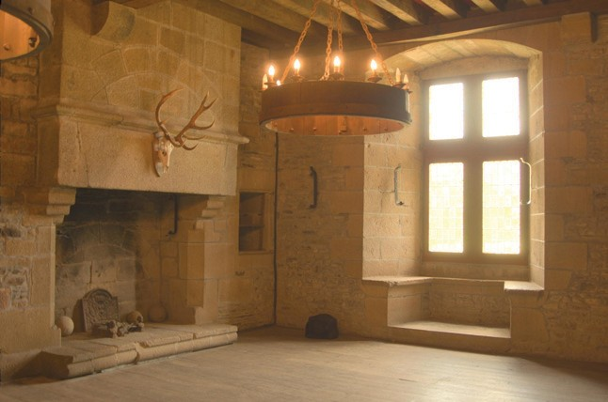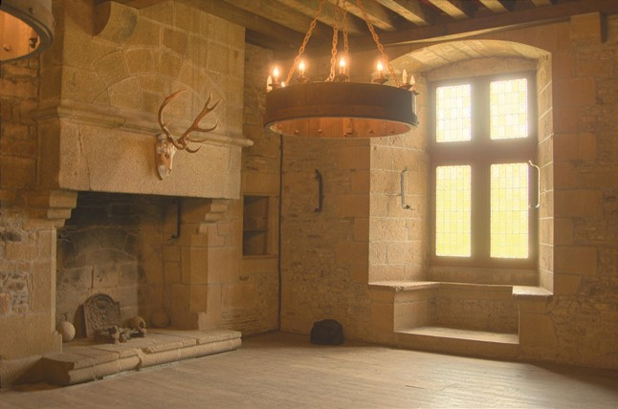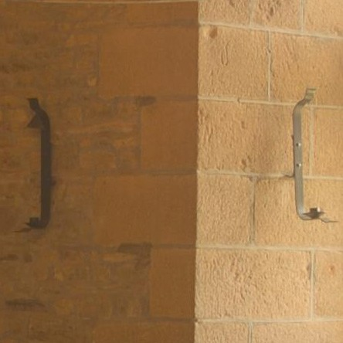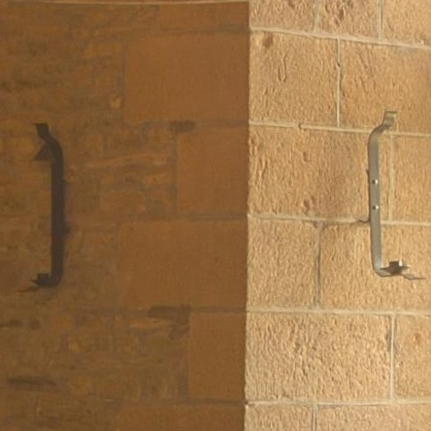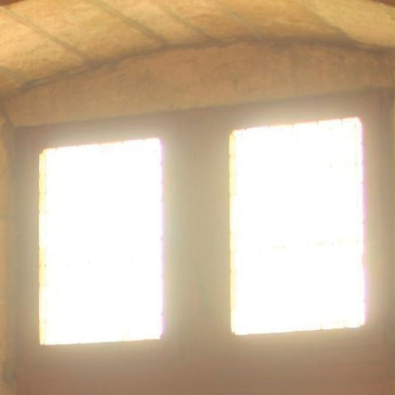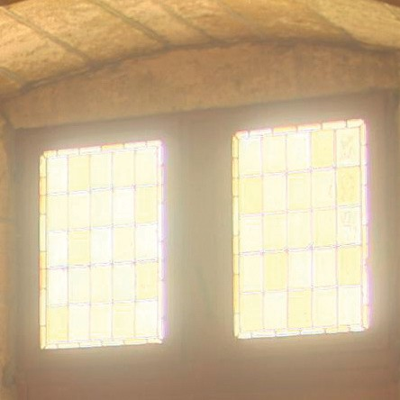

**Figure 21.19.** A global tone reproduction operator (left) and a local tone reproduction operator (right) (Reinhard, Stark, Shirley, & Ferwerda, 2002) of each image. The local operator shows more detail; for example, the metal badge on the right shows better contrast and the highlights are crisper.

following two functional forms:

*L* (*x, y*) = *Lv*(*x, y*) *,* (21.2)

*d f* (*x, y*)

*Lv*(*x, y*)

*L* (*x, y*) = *.* (21.3)

*d Lv*(*x, y*)+ *fn*(*x, y*)

In these equations, *f* (*x, y*) may either be a constant or a function which varies per pixel. In the former case, we have a global operator, whereas a spatially varying function *f* (*x, y*) results in a local operator. The exponent *n* is usually a constant which is fixed for a particular operator.

Equation (21.2) divides each pixel’s luminance by a value derived from either the full image or a local neighborhood. Equation (21.3) has an S-shaped curve on a log-linear plot and is called a sigmoid for that reason. This functional form fits data obtained from measuring the electrical response of photoreceptors to flashes of light in various species. In the following sections, we discuss both functional forms.

## Division

Each pixel may be divided by a constant to bring the high dynamic range image within a displayable range. Such a division essentially constitutes linear scaling, as shown in Figure 21.3. While Figure 21.3 shows ad-hoc linear scaling, this approach may be refined by employing psychophysical data to derive the scaling constant *f* (*x, y*) = *k* in Equation (21.2) (G. J. Ward, 1994; Ferwerda, Pattanaik, Shirley, & Greenberg, 1996).

Alternatively, several approaches exist that compute a spatially varying di- visor. In each of these cases, *f* (*x, y*) is a blurred version of the image, i.e., *f* (*x, y*) = *L*blur(*x, y*). The blur is achieved by convolving the image with a Gaussian filter (Chiu et al., 1993; Rahman, Jobson, & Woodell, 1996). In addi-

*v*

tion, the computation of *f* (*x, y*) by blurring the image may be combined with a shift in white point for the purpose of color appearance modeling (Fairchild & Johnson, 2002; G. M. Johnson & Fairchild, 2003; Fairchild & Johnson, 2004).

The size and the weight of the Gaussian filter has a profound impact on the resulting displayable image. The Gaussian filter has the effect of selecting a weighted local average. Tone reproduction is then a matter of dividing each pixel by its associated weighted local average. If the size of the filter kernel is chosen too small, then haloing artifacts will occur (Figure 21.20 (left)). Haloing is a com- mon problem with local operators and is particularly evident when tone mapping relies on division.

**Figure 21.20.** Images tonemapped by dividing by Gaussian-blurred versions. The size of the filter kernel is 64 pixels for the left image and 512 pixels for the right image. For division-based algorithms, halo artifacts are minimized by choosing large filter kernels.

In general, haloing artifacts may be minimized in this approach by making the filter kernel large (Figure 21.20 (right)). Reasonable results may be obtained by choosing a filter size of at least one quarter of the image. Sometimes even larger filter kernels are desirable to minimize artifacts. Note, that in the limit, the filter size becomes as large as the image itself. In that case, the local operator becomes global, and the extra compression normally afforded by a local approach is lost.

The functional form whereby each pixel is divided by a Gaussian-blurred pixel at the same spatial position thus requires an undesirable tradeoff between amount of compression and severity of artifacts.

## Sigmoids

Equation (21.3) follows a different functional form from simple division, and, therefore, affords a different tradeoff between amount of compression, presence of artifacts, and speed of computation.

Sigmoids have several desirable properties. For very small luminance values, the mapping is approximately linear, so that contrast is preserved in dark areas of the image. The function has an asymptote at one, which means that the output mapping is always bounded between 0 and 1.

In Equation (21.3), the function *f* (*x, y*) may be computed as a global con-

stant or as a spatially varying function. Following common practice in electro- physiology, we call *f* (*x, y*) the *semi-saturation* constant. Its value determines which values in the input image are optimally visible after tonemapping. In par- ticular, if we assume that the exponent *n* equals 1, then luminance values equal to the semi-saturation constant will be mapped to 0*.*5. The effect of choosing different semi-saturation constants is shown in Figure 21.21.

1.0

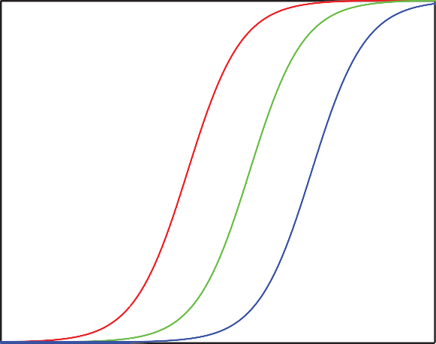

*Ld = Lw* / (*Lw* + 1) *Ld = Lw* / (*Lw* + 10) *Ld = Lw* / (*Lw* + 100)

*Ld*

0.9

0.8

0.7

0.6

0.5

0.4

0.3

0.2

0.1

0.0

10-3 10-2 10-1 100 101 102 103

104

*L*

*w*

**Figure 21.21.** The choice of semi-saturation constant determines how input values are mapped to display values.

The function *f* (*x, y*) may be computed in several different ways (Reinhard et al., 2005). In its simplest form, *f* (*x, y*) is set to *L*¯*v/k*, so that the geometric

average is mapped to user parameter *k* (Figure 21.22) (Reinhard et al., 2002). In this case, a good initial value for *k* is 0*.*18, although for particularly bright or dark scenes this value may be raised or lowered. Its value may be estimated from the image itself (Reinhard, 2003). The exponent *n* in Equation (21.3) may be set to 1. In this approach, the semi-saturation constant is a function of the geometric

average, and the operator is therefore global. A variation of this global opera- tor computes the semi-saturation constant by linearly interpolating between the

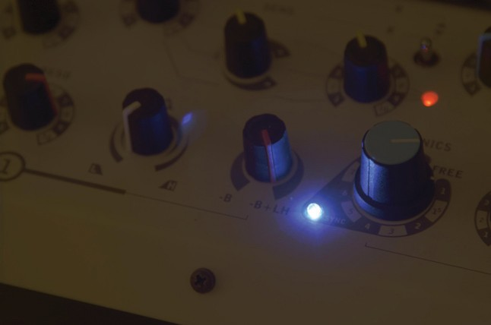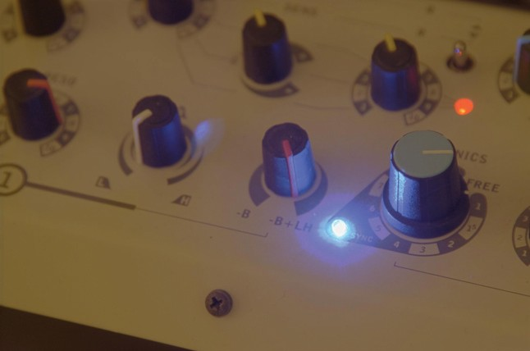

**Figure 21.22.** A linearly scaled image (left) and an image tonemapped using sigmoidal compression (right).

**Figure 21.23.** Linear interpolation varies contrast in the tonemapped image. The parameter *a* is set to 0.0 in the left image, and to 1.0 in the right image.

geometric average and each pixel’s luminance:

*f* (*x, y*) = *a Lv*(*x, y*)+ (1 *− a*) *L*¯*v.*

The interpolation is governed by user parameter *a* which has the effect of vary- ing the amount of contrast in the displayable image (Figure 21.23) (Reinhard & Devlin, 2005). More contrast means less visible detail in the light and dark areas and vice versa. This interpolation may be viewed as a halfway house between a fully global and a fully local operator by interpolating between the two extremes without resorting to expensive blurring operations.

Although operators typically compress luminance values, this particular op- erator may be extended to include a simple form of chromatic adaptation. It thus presents an opportunity to adjust the level of saturation normally associated with tonemapping, as discussed at the beginning of this chapter.

Rather than compress the luminance channel only, sigmoidal compression is applied to each of the three color channels:

*Ir,d Ig,d Ib,d*

*Ir*(*x, y*) (*x, y*) = *I* (*x, y*)+ *fn*(*x, y*) *,*

*Ig*(*x, y*) (*x, y*) = *I* (*x, y*)+ *fn*(*x, y*) *,*

*r*

*g*

*Ib*(*x, y*) (*x, y*) = *I* (*x, y*)+ *fn*(*x, y*) *.*

*b*

The computation of *f* (*x, y*) is also modified to bilinearly interpolate between the

geometric average luminance and pixel luminance and between each independent color channel and the pixel’s luminance value. We therefore compute the geo-

metric average luminance value *L*¯*v*, as well as the geometric average of the red,

green, and blue channels (*I*¯*r* , *I*¯*g* , and *I*¯*b*). From these values, we compute *f* (*x, y*)

for each pixel and for each color channel independently. We show the equation

**Figure 21.24.** Linear interpolation for color correction. The parameter *c* is set to 0.0 in the left image, and to 1.0 in the right image.

for the red channel (*fr*(*x, y*)):

*Gr*(*x, y*) = *c Ir*(*x, y*)+ (1 *− c*) *Lv*(*x, y*)*, G*¯*r* (*x, y*) = *c I*¯*r* + (1 *− c*) *L*¯*v,*

*fr*(*x, y*) = *a Gr*(*x, y*)+ (1 *− a*) *G*¯*r* (*x, y*)*.*

The interpolation parameter *a* steers the amount of contrast as before, and the new interpolation parameter *c* allows a simple form of color correction (Figure 21.24). So far we have not discussed the value of the exponent *n* in Equation (21.3).

Studies in electrophysiology report values between *n* = 0*.*2 and *n* = 0*.*9 (Hood, Finkelstein, & Buckingham, 1979). While the exponent may be user-specified, for

a wide variety of images we may estimate a reasonable value from the geometric average luminance *L*¯*v* and the minimum and maximum luminance in the image (*L*min and *L*max) with the following empirical equation:

*n* = 0*.*3+ 0*.*7

. *L*max

*− L*¯*v*

1*.*4

*.*

Σ

*L*max *− L*min

The several variants of sigmoidal compression shown so far are all global in na- ture. This has the advantage that they are fast to compute, and they are very suitable for medium to high dynamic range images. For very high dynamic range images, it may be necessary to resort to a local operator, since this may give some extra compression. A straightforward method to extend sigmoidal compression replaces the global semi-saturation constant by a spatially varying function, which may be computed in several different ways.

In other words, the function *f* (*x, y*) is so far assumed to be constant, but may also be computed as a spatially localized average. Perhaps the simplest way to

accomplish this is to once more use a Gaussian-blurred image. Each pixel in

a blurred image represents a locally averaged value which may be viewed as a suitable choice for the semi-saturation constant1.

As with division-based operators discussed in the previous section, we have to consider haloing artifacts. However, when an image is divided by a Gaussian- blurred version of itself, the size of the Gaussian filter kernel needs to be large in order to minimize halos. If sigmoids are used with a spatially variant semi- saturation constant, the Gaussian filter kernel needs to be made small in order to minimize artifacts. This is a significant improvement, since small amounts of Gaussian blur may be efficiently computed directly in the spatial domain. In other words, there is no need to resort to expensive Fourier transforms. In practice, filter kernels of only a few pixels width are sufficient to suppress significant artifacts while at the same time producing more local contrast in the tonemapped images. One potential issue with Gaussian blur is that the filter blurs across sharp contrast edges in the same way that it blurs small details. In practice, if there

is a large contrast gradient in the neigh- borhood of the pixel under considera- tion, this causes the Gaussian-blurred pixel to be significantly different from the pixel itself. This is the direct cause for halos. By using a very large fil- ter kernel in a division-based approach, such large contrasts are averaged out.

In sigmoidal compression schemes,

**Figure 21.25.** Example image used to demon- strate the scale selection mechanism shown in Figure 21.26.

a small Gaussian filter minimizes the chances of overlapping with a sharp contrast gradient. In that case, halos still occur, but their size is such that they

usually go unnoticed and instead are perceived as enhancing contrast.

Another way to blur an image, while minimizing the negative effects of nearby large contrast steps, is to avoid blurring over such edges. A simple, but compu- tationally expensive way, is to compute a stack of Gaussian-blurred images with different kernel sizes. For each pixel, we may choose the largest Gaussian that does not overlap with a significant gradient.

In a relatively uniform neighborhood, the value of a Gaussian-blurred pixel should be the same regardless of the filter kernel size. Thus, the difference be- tween a pixel filtered with two different Gaussians should be approximately zero. This difference will only change significantly if the wider filter kernel overlaps

1 Although *f* (*x, y*) is now no longer a constant, we continue to refer to it as the semi-saturation

constant.

**Figure 21.26.** Scale selection mechanism: the left image shows the scale selected for each pixel of the image shown in Figure 21.25; the darker the pixel, the smaller the scale. A total of eight different scales were used to compute this image. The right image shows the local average computed for each pixel on the basis of the neighborhood selection mechanism.

with a neighborhood containing a sharp contrast step, whereas the smaller filter kernel does not.

It is possible, therefore, to find the largest neighborhood around a pixel that does not contain sharp edges by examining differences of Gaussians at different kernel sizes. For the image shown in Figure 21.25, the scale selected for each pixel is shown in Figure 21.26 (left). Such a scale selection mechanism is employed by the photographic tone reproduction operator (Reinhard et al., 2002) as well as in Ashikhmin’s operator (Ashikhmin, 2002).

Once the appropriate neighborhood for each pixel is known, the Gaussian- blurred average *L*blur for this neighborhood (shown on the right of Figure 21.26) may be used to steer the semi-saturation constant, such as for instance employed by the photographic tone reproduction operator:

*L*w

*L*d = *.*

1+ *L*blur

An alternative, and arguably better, approach is to employ edge-preserving smoothing operators, which are designed specifically for removing small details while keeping sharp contrasts in tact. Several such filters, such as the bilateral filter (Figure 21.27), trilateral filter, Susan filter, the LCIS algorithm and the mean shift algorithm are suitable, although some of them are expensive to com- pute (Durand & Dorsey, 2002; Choudhury & Tumblin, 2003; Pattanaik & Yee, 2002; Tumblin & Turk, 1999; Comaniciu & Meer, 2002).

## Other Approaches

Although the previous sections together discuss most tone reproduction operators to date, there are one or two operators that do not directly fit into the above cate-

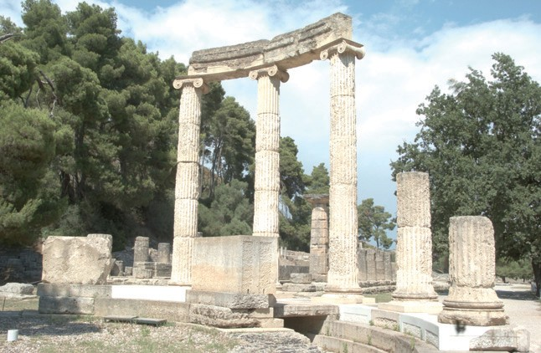 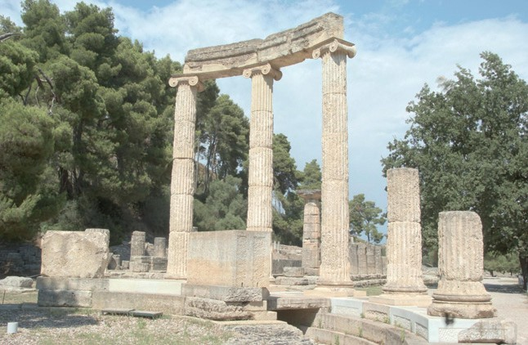

**Figure 21.27.** Sigmoidal compression (left) and sigmoidal compression using bilateral filtering to compute the semi-saturation constant (right). Note the improved contrast in the sky in the right image.

gories. The simplest of these are variations of logarithmic compression, and the other is a histogram-based approach.

Dynamic range reduction may be accomplished by taking the logarithm, pro- vided that this number is greater than 1. Any positive number may then be non- linearly scaled between 0 and 1 using the following equation:

*L* (*x, y*) = log*b*(1 + *Lv*(*x, y*)) *.*

*d*

log*b*(1 + *L*max)

While the base *b* of the logarithm above is not specified, any choice of base will do. This freedom to choose the base of the logarithm may be used to vary the base with input luminance, and thus achieve an operator that is better matched to the image being compressed (Drago, Myszkowski, Annen, & Chiba, 2003). This method uses Perlin and Hoffert’s bias function which takes user parameter *p* (Perlin & Hoffert, 1989):

bias*p*(*x*) = *x*log10 (*p*)*/* log10 (1*/*2)*.*

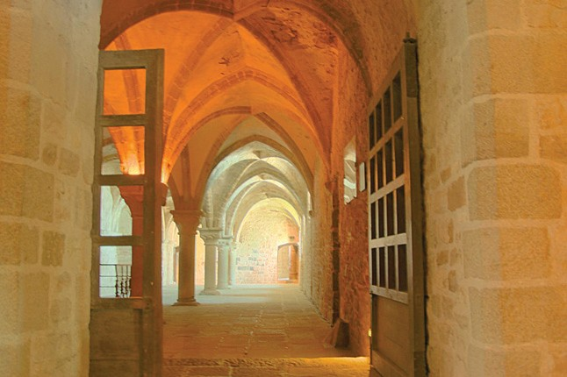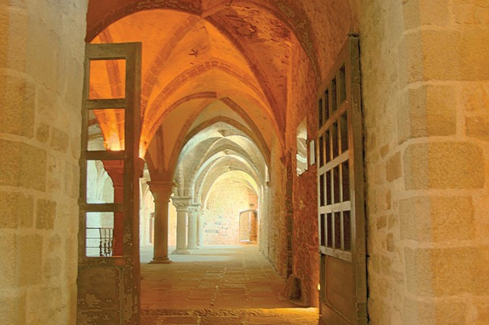

**Figure 21.28.** Logarithmic compression using base 10 logarithms (left) and logarithmic compres- sion with varying base (right).

Making the base *b* dependent on luminance and smoothly interpolating bases be- tween 2 and 10, the logarithmic mapping above may be refined:

*Ld*(*x, y*) =

log10(1 + *Lv*(*x, y*)) log10(1 + *L*max)

*·*

log10

.2+8

1

.. *Lv*(*x, y*) Σlog10

*L*

(*p*)*/* log10

(1*/*2)ΣΣ *.*

max

For user parameter *p*, an initial value of around 0*.*85 tends to yield plausible results (Figure 21.28 (right)).

Alternatively, tone reproduction may be based on histogram equalization. Tra- ditional histogram equalization aims to give each luminance value equal probabil- ity of occurrence in the output image. Greg Ward refines this method in a manner that preserves contrast (Ward Larson, Rushmeier, & Piatko, 1997).

First, a histogram is computed from the luminances in the high dynamic range image. From this histogram, a cumulative histogram is computed such that each bin contains the number of pixels that have a luminance value less than or equal to the luminance value that the bin represents. The cumulative histogram is a monotonically increasing function. Plotting the values in each bin against the luminance values represented by each bin therefore yields a function which may be viewed as a luminance mapping function. Scaling this function, such that the vertical axis spans the range of the display device, yields a tone reproduction operator. This technique is called histogram equalization.

Ward further refined this method by ensuring that the gradient of this function never exceeds 1. This means, that if the difference between neighboring values in the cumulative histogram is too large, this difference is clamped to 1. This avoids the problem that small changes in luminance in the input may yield large

differences in the output image. In other words, by limiting the gradient of the cumulative histogram to 1, contrast is never exaggerated. The resulting algorithm is called histogram adjustment (see Figure 21.29).

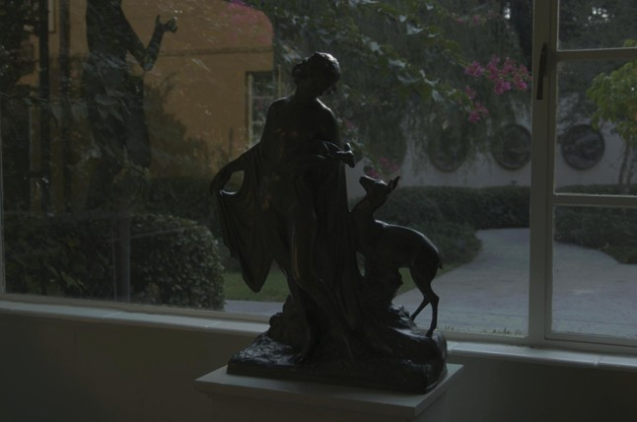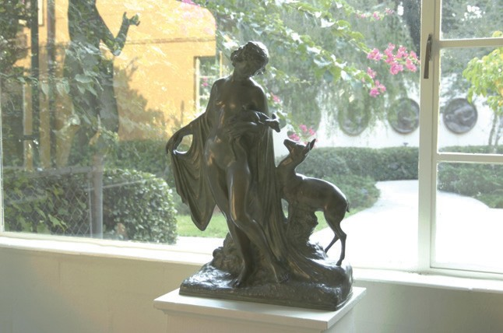

**Figure 21.29.** A linearly scaled image (left) and a histogram adjusted image (right). *Image created with the kind permission of the Albin Polasek museum, Winter Park, Florida.*

* 1. Night Tonemapping 581

## Night Tonemapping

The tone reproduction operators discussed so far nearly all assume that the im- age represents a scene under *photopic* viewing conditions, i.e., as seen at normal light levels. For *scotopic* scenes, i.e., very dark scenes, the human visual system exhibits distinctly different behavior. In particular, perceived contrast is lower, visual acuity (i.e., the smallest detail that we can distinguish) is lower, and every- thing has a slightly blue appearance.

To allow such images to be viewed correctly on monitors placed in photopic lighting conditions, we may preprocess the image such that it appears as if we were adapted to a very dark viewing environment. Such preprocessing frequently takes the form of a reduction in brightness and contrast, desaturation of the im- age, blue shift, and a reduction in visual acuity (Thompson, Shirley, & Ferwerda, 2002).

A typical approach starts by converting the image from RGB to XYZ. Then, scotopic luminance *V* may be computed for each pixel:

*V* = *Y* Σ1*.*33 .1+ *Y* + *Z* Σ *−* 1*.*68Σ *.*

*X*

This single channel image may then be scaled and multiplied by an em- pirically chosen bluish gray. An example is shown in Figure 21.30. If some

pixels are in the photopic range, then the night image may be created by lin- early blending the bluish-gray image with the input image. The fraction to use for each pixel depends on *V* .

Loss of visual acuity may be mod- eled by low-pass filtering the night im- age, although this would give an incor- rect sense of blurriness. A better ap-

**Figure 21.30.** Simulated night scene using the image shown in Figure 21.12.

proach is to apply a bilateral filter to re- tain sharp edges while blurring smaller details (Tomasi & Manduchi, 1998).

Finally, the color transfer technique outlined in Section 21.3 may also be used to transform a day-lit image into a night scene. The effectiveness of this approach depends on the availability of a suitable night image from which to transfer colors. As an example, the image in Figure 21.12 is transformed into a night image in Figure 21.31.

 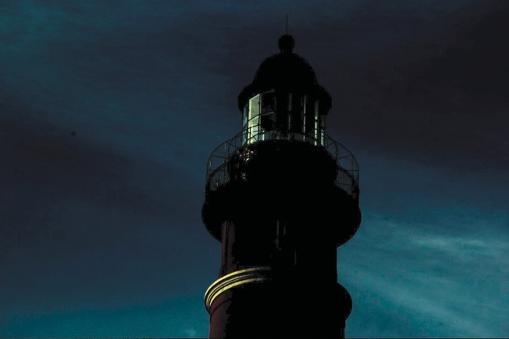

**Figure 21.31.** The image on the left is used to transform the image of Figure 21.12 into a night scene, shown here on the right.

## Discussion

Since global illumination algorithms naturally produce high dynamic range im- ages, direct display of the resulting images is not possible. Rather than resort to linear scaling or clamping, a tone reproduction operator should be used. Any tone reproduction operator is better than using no tone reproduction. Dependent on the requirements of the application, one of several operators may be suitable.

For instance, real-time rendering applications should probably resort to a sim- ple sigmoidal compression, since these are fast enough to also run in real time. In addition, their visual quality is often good enough. The histogram adjustment technique (Ward Larson et al., 1997) may also be fast enough for real-time oper- ation.

For scenes containing a very high dynamic range, better compression may be achieved with a local operator. However, the computational cost is frequently substantially higher, leaving these operators suitable only for noninteractive ap- plications. Among the fastest of the local operators is the bilateral filter due to the optimizations afforded by this technique (Durand & Dorsey, 2002).

This filter is interesting as a tone reproduction operator by itself, or it may be used to compute a local adaptation level for use in a sigmoidal compression function. In either case, the filter respects sharp contrast changes and smoothes over smaller contrasts. This is an important feature that helps minimize halo artifacts, which are a common problem with local operators.

An alternative approach to minimize halo artifacts is the scale selection mech- anism used in the photographic tone reproduction operator (Reinhard et al., 2002), although this technique is slower to compute.

In summary, while a large number of tone reproduction operators is cur- rently available, only a small number of fundamentally different approaches exist. Fourier-domain and gradient-domain operators are both rooted in knowledge of

* 1. Discussion 583

image formation. Spatial-domain operators are either spatially variant (local) or global in nature. These operators are usually based on insights gained from study- ing the human visual system (and the visual system of many other species).

l

|  |  |  |
| --- | --- | --- |
|  | Brian | Wyvil |
|  | 22 |  |
|  |  |  |

# Implicit Modeling

Implicit modeling (also known as implicit surfaces) in computer graphics covers many different methods for defining models. These include *skeletal implicit mod- eling*, *offset surfaces*, *level sets*, *variational surfaces*, and *algebraic surfaces*. In this chapter, we briefly touch on these methods and describe how to build skeletal implicit models in more detail. Curves can be defined by implicit equations of the form

*f* (*x, y*) = 0*.*

If we consider a closed curve, such as a circle, with radius *r*, then the implicit equation can be written as

*f* (*x, y*) = *x*2 + *y*2 *− r*2 = 0*.* (22.1)

The value of *f* (*x, y*) can be positive (outside the circle), negative (inside the circle), or zero for points precisely on the circle. The equivalent in three dimen- sions is a closed surface around a set of points that occupy a given volume or region of space. The volume forms a scalar field, i.e., we can compute a value for

every point and as can be seen for the circle, the negative values are bounded by the implicit curve or surface. The surface can be visualized as a contour in the field, connecting points with a particular value such as zero (see Equation (22.1)). To compute such a surface implies searching through space to find the points that satisfy the implicit equation; this method is unlikely to lead to an efficient al- gorithm for circle drawing (and even less likely in three dimensions). This was perhaps the reason that algorithmic methods for modeling with parametric curves

585